SimpleCRM Functional Specification for Commercial Bank
CRM- Service Management
Ganesh Nagaraja
Monday, March02, 2020
Version 6.1
Revision history

Version | Date | Description of changes | Reason | Author
1.0 | Wednesday, January 22, 2020 | Initial Draft | Initial draft
2.0 | Monday, 27 January 2020 | Updated customer Module, Ticket Module and Email Flows between customer, branch and department  Updated Email Communications between departments | Updates to Flows | Ganesh Nagaraja
3.0 | Tuesday, 25 February 2020 | Merging of Contents from feedback from Commercial Bank | Update of Chatbot Flows | Ganesh Nagaraja
4.0 | Monday, 02 March 2020 | Customer Category | Added BIZ CLUB category | Ravin Ratnasekera
 | Monday, 02 March 2020 | 360 Degree Pop-up Layout | 360 Degree Pop-up Layout | Ganesh Nagaraja
5.1 |  | Additional Fields details added |  | Thushita
6 | Wednesday, 18 March 2020 | 360 Degree Pop-up Layout | 360 Degree Pop-up Layout | Ganesh Nagaraja
6.1 | Wednesday, 13 May 2020 | Updated customer Search feature for Portal |  | Ganesh Nagaraja

Approvals
Version | Date | Approved by | Organization | Signature
6.0 |  | Commercial Bank

Contents
1. References 8
2. Introduction 9
2.1. List of Abbreviations/Terminologies 9
2.2. Scope 10
2.3. Out of Scope 28
3. Overview of Solution 28
3.1. Supported functionalities 28
3.2. Solution architecture 29
3.3. Network Architecture 30
4. Integration Process 32
5. Entity Relationship Diagram 33
6. System Overview (Service Management) 34
Customer Calling Call Centre (Verification Questions) 35
Current Process: 36
To Be process: 36
Customer visit to the branch 37
Customer Self Service using Chatbot 38
To Be Process: 38
7. Functional Requirements 39
7.1. Detailed Requirements 39
7.1.1. Managing Customer information 39
Requirement [RQ.1.0.0.2]: NIC Search Logic 41
Requirement [RQ.1.0.0.3]: Calculate Age based on Date of birth 41
Requirement [RQportal.1.0.0.4]: Gender identification of the customer 42
Requirement [RQ.1.0.0.5]: Random Verification question 43
Requirement [RQ.1.0.0.6]: Daily Sync Updates/Creation of Customer, Accounts, Cards and Loan Data 43
Requirement [RQ.1.0.0.6]: REST API for Creation of Customer, Accounts, Cards 46
Requirement [RQ.1.0.0.7]: Ximager Storage for retrieving Customer Photo 46
Requirement [RQ.1.0.0.8]: Customer Search Capability 46
Requirement [RQ.1.0.0.9]: Verification Question 48
7.1.2. Managing AccountInformation 48
Requirement [RQ.2.0.0.1]: Account Information 48
7.1.3. Managing Card Information 51
Requirement [RQ.2.0.0.2]: Card Information 51
7.1.4. Managing Loan Details 53
Requirement [RQ.2.0.0.3]: Loan Information 53
7.1.5. Customer 360 Degree 55
Requirement [RQ.2.0.0.4]: 360 Degree – Pop-Up Screen Layout 55
7.1.6. Managing Ticket information 58
Requirement [RQ.3.0.0.1]: Ticket Information 58
Requirement [RQ.3.0.0.2]: Inbound Email Case creation process 61
To Be Process: 62
CRM and Portal Interaction Matrix 63
Process for Tasks 65
Email Communication between branch, department and the customer 66
7.1.7. Workflows&Ticket Assignment Rule 67
Requirement [RQ.3.0.0.3]: Workflow Configurations 67
Requirement [RQ.3.0.0.4]: Working Hour configurations 67
Requirement [RQ.3.0.0.5]: Holiday Calander 67
Requirement [RQ.3.0.0.6]: Recalcuate SLA 67
Requirement [RQ.3.0.0.7]: Assignment Rule for Tickets 68
8. Email/SMS Notifications & Templates 69
8.1. Email Notifications – Auto Generated 69
Requirement [RQ.1.0.0.14]: Send Email Notifications on Ticket Create 69
8.2. SMS Notifications 73
8.2.1. Managing Ticket – Closure Feedback information<SAMPLE> 75
9. SMTP Settings 75
10. View Integration Data 76
11. CRM and Portal Users 78
12. Application Users, Security Groups and Roles 79
Requirement [AD.1.0.0.1]: Creation of Security Group 81
Requirement [AD.1.0.0.2]: Creation of Roles 82
Requirement [AD.1.0.0.3]: Default Role 82
12.1. Basic System Setup for each User 82
13. CTI Integration 82
13.1.1. 360 Degree Pop-up 82
13.2. Appendix B - Advanced Workflow and Assignment Rules 84
14. Reports 84
15. Daily Sync 84
16. Branch Support Portal 84
16.1.1. Dashboard 86
16.1.2. Customer Search 87
16.1.3. Case Search 88
16.1.4. Create/Edit Case 88
16.1.5. View Case 89
16.1.6. Create Tasks/Notes 91
16.1.7. Close Task 91
16.1.8. Close Case 91
17. Reports 92
17.1.1. Reports – Age of Grievence 92
17.2. Reports – Case Priority Count 93
17.3. Reports – Case Type Count 94
18. Chatbot Flows 95
18.1. Top View of Chatbot Flows 96
18.1.1. Current and Saving Products 97
18.1.2. Fixed Diposits and Tresury Bills 98
18.1.3. Loan and Leasing Details 99
18.1.4. Cards 100
18.1.5. Digital Banking Products 101
18.1.6. Other Products 102
18.2. My Products Top View 103
18.2.1. My Current and Saving Products 104
18.2.2. My Fixed Deposits and Treasury Bills 106
18.2.3. My Loan Details 107
18.2.4. My Card Details 108

References

Following are documents are used in this document as a reference:

# | Title
 | Products.xlsx – List of all the products used at Commercial Bank
 | Modules- ComBank- SW- Model Definition Template
 | User Roles SimpleCRM
 | Employee Information for Simple CRM.xls- List of Users

Introduction

This document details out the configurations and customizations to be done on SimpleCRM platform to meet Commerical Bank’s requirements on Customers, Account Management, and Service Tickets.

The key expectations from SimpleCRM:

- CRM - Customer Relationship Management
- Support Management –
  - Customers
  - Accounts
  - Cards
  - Loans
  - Products
  - Activities Transacted (Inbound, SMS Sent, Emails Sent, Tasks)
  - Branches& ATM
  - Interest Rates
  - Forex Rates
  - Cases

List of Abbreviations/Terminologies

Following are the generic terms used throughout by various departments using the system.

Term | Definition
COM BANK | Commercial Bank
CRM | Customer Relationship Management
MBD | Manager of Business Development
CC | Customer care
CS | Customer Service
WF | Workflow

Scope

Following items listed below are inscope as part of support automation

REQUIREMENT TYPE | REQUIREMENT DESCRIPTION | USERS | COMMENTS
IVR | Facilitate to prompt the customer details on-screen by capturing the incoming telephone number of the customer | CC | The various Scenarios described under the following Section  CTI Integration
Customer Searching | Customers can be identified by querying them based on  NIC  Passport No.  Driving License No. (***)  Account No.  Mobile No.  Telephone Number  Date of Birth  E-mailAddress  Ticket No.  The searching facility should be capable of querying the Customer based on information. | CC | Requirement [RQ.1.0.0.2]: NIC Search Logic
PERSONAL PORTAL

 | CUSTOMER TYPE | CS / CC / | P /N (Personal/ Non-personal)  CUPERS in CUP003/ICBSPRDDT1
Customer details  ** A Flip Tile to be attached to check the Verification Questions | Photograph | CS / CC / | Pick the photo from the latest opened A/C through a link to Ximager Storage
 | Salutation |  | To be reserved to be introduced later
 | Customer Full Name | CS / CC / | CUNA1 in CUP00301/ICBSPRDDT1
 | Customer Short Name |  | CUSHRT in CUP00301/ICBSPRDDT1
 | NIC Number/Business reg. No | CS / CC / | CUNTID in CUP00301/ICBSPRDDT1
 | Passport Number |  | CUCPSP inCUP00301/ICBSPRDDT1
 | Driving License Number |  | N/A
 | Date of Birth: <Age> |  | CUBDTE in CUP00301/ICBSPRDDT1 (stored as aJulian date)  Requirement [RQ.1.0.0.3]: Calculate Age based on Date of birth
 | Gender | CS / CC / | CUSEX in CUP00301/ICBSPRDDT1  Requirement [RQ.1.0.0.4]: Gender identification of the customer
 | Customer Category - Personal | CS / CC / | Elite – Customer who is having accounts under Br code 169 or Customer who is having accounts with officer code “ESC” from any branch to be classified as elite customers.  Staff - CUUSR1 IN CUP003 (Value to be matched with yellow pages database)  Ex-staff - CUUSR1 IN CUP003 which includes the phrase “RTD” ex. RTD0040  Premium Card Holder  Islamic Banking - Customer who is having accounts under Br code 901  PEP(Politically Exposed Person) - CUUSR1 IN CUP003 which includes the phrase “PEP”  FATCA - CUUSR1 IN CUP003 which includes the phrase “FATCA” or “USA”  BIZ CLUB – CHCRTY in ZCMSCH0P/ ASID119001 , CHPART = '001' & CHCRTY LIST ‘MBZ’ ‘MCB’
 | Customer Priority | CS / CC / | 1 Premium 2 Platinum 3 General (Not shown to the user on the UI)
 | Sensitivity Category | CS / CC / | Friendly/ Moderate/ Aggressive/ Handle with care
 | Customer Verification Password | CS / CC /
 | Mobile number – CBS (Core Banking System) | CS / CC | CUCLPH in Cup00301
 | Mobile number – CMS (Card Management System) | CS / CC | PHPHON IN ZCDBPH0P
 | Telephone number - CBS | CS / CC | CUHMPH and CUBUPH in Cup00301
 | Telephone number – CMS | CS / CC | PHPHPON IN ZCDBPH0P
 | Email address –CBS | CS / CC | CUEMA1 and CUEMA2 in Cup00301
 | Email address –CMS | CS / CC | EMEMAL IN ZCDBEM0P
 | Correspondence Address – CBS | CS / CC | CUNA2  CUNA3  CUNA4  CUNA5  CUNA6  In CUP00301
 | Correspondence Address – CMS | CS / CC | ADADR1&ADADR2 &ADCITY IN ZCDBAD0P
 | Mother’s Maiden Name | CS/CC | PDMMDN IN ZCDBAD0P
 | Occupation | CS / CC / | CUSIC IN CUP00301  Description to be matched by FRP005/ICBSPRDDT1  FVAPP Application Number  FVFLD Field/Table Name  FVVAL Field Value  FVDSC1 Description  Provide MIT with a table of SIC codes to be uploaded to CRM – Both SIC Code & the Description to be shown in the system – from CBS
 | Customer other relationships |  | CUP020 / ICBSPRDDT1  CUNBR1 Customer CIF Key  CUNBR2 Customer CIF Key  CUREL Relationship  Description to be obtained from CFP951/ICBSPRDDT1  CFRELC Relationship Code  CFRELD Relationship Description  Director, Partner, Proprietor ,etc& the company . ( Using customer to customer relationship function) – Customer to Customer relationship file
 | E KYC (***) |  | Link to a portal. Display a separate page
 | CRIB Details |  | Link to a portal. Display a separate page
 | Customer profitability |  | Link to a portal. Display a separate page
 | Preferred language |  | To be automatically updated to the CRM from the Language they selected when calling through IVR  Field to be opened for editing by a supervisor

CORPORATE PORTAL
 | CUSTOMER TYPE | CS / CC / | P /N(Personal/ Non-personal)  CUPERS in CUP003/ICBSPRDDT1
Customer details  ** A Flip Tile to be attached to check the | Business Type |  | PLC, Sole Proprietorship. Partnership  B_CUSTTYPE in KYC_N00001/SAS_STGMAL  Matched from CIF no  CIFNO  B_CUSTTYPE
Customer details  ** A Flip Tile to be attached to check the | Company Name | CS / CC /
Customer details  ** A Flip Tile to be attached to check the | Related Party Details |  | CUP020 / ICBSPRDDT1  CUNBR1 Customer CIF Key  CUNBR2 Customer CIF Key  CUREL Relationship  Description to be obtained from CFP951/ICBSPRDDT1  CFRELC Relationship Code  CFRELD Relationship Description  Directors, Partners, Chairman , etc ..
Customer details  ** A Flip Tile to be attached to check the | Business Registration Number | CS / CC /
Customer details  ** A Flip Tile to be attached to check the | Customer Category | CS / CC /
Customer details  ** A Flip Tile to be attached to check the | Customer Priority | CS / CC / | 1 Premium 2 Platinum 3 General (Not shown to the user on the UI)
Customer details  ** A Flip Tile to be attached to check the | Sensitivity Category | CS / CC / | Friendly/ Moderate/ Aggressive/ Handle with care
Customer details  ** A Flip Tile to be attached to check the | Customer Verification Password | CS / CC /
Customer details  ** A Flip Tile to be attached to check the | Mobile number – CBS (Core Banking System) | CS / CC | CUCLPH in Cup00301
Customer details  ** A Flip Tile to be attached to check the | Mobile number – CMS (Card Management System) | CS / CC | PHPHON IN ZCDBPH0P
Customer details  ** A Flip Tile to be attached to check the | Telephone number - CBS | CS / CC | CUHMPH and CUBUPH in Cup00301
Customer details  ** A Flip Tile to be attached to check the | Telephone number – CMS | CS / CC | PHPHON IN ZCDBPH0P
Customer details  ** A Flip Tile to be attached to check the | Email address –CBS | CS / CC | EMEMAL IN ZCDBEM0P
Customer details  ** A Flip Tile to be attached to check the | Email address –CMS | CS / CC | CUEMA1 and CUEMA2 in Cup00301
Customer details  ** A Flip Tile to be attached to check the | Correspondence Address – CBS | CS / CC | CUNA2  CUNA3  CUNA4  CUNA5  CUNA6  In CUP00301
Customer details  ** A Flip Tile to be attached to check the | Correspondence Address – CMS | CS / CC | ADADR1&ADADR2 &ADCITY IN ZCDBAD0P
Customer details  ** A Flip Tile to be attached to check the | Business Sector | CS / CC / | CUSIC IN CUP00301  Description to be matched by FRP005/ICBSPRDDT1  FVAPP Application Number  FVFLD Field/Table Name  FVVAL Field Value  FVDSC1 Description  Provide MIT with a table of SIC codes to be uploaded to CRM – Both SIC Code & the Description to be shown in the system – from CBS
Customer details  ** A Flip Tile to be attached to check the | E KYC (***) |  | Link to a portal. Display a separate page
Customer details  ** A Flip Tile to be attached to check the | CRIB Details |  | Link to a portal. Display a separate page
Customer details  ** A Flip Tile to be attached to check the | Customer profitability |  | Link to a portal. Display a separate page
Customer details  ** A Flip Tile to be attached to check the | Preferred language |  | To be automatically updated to the CRM from the Language they selected when calling through IVR  Field to be opened for editing by a supervisor

Account Details | Savings  ** A Flip Tile to be attached to check the followings**  -Account Number  DMACCT in Tap002/ICBSPRDDT1  - Product Type  DMTYPE in Tap002/ICBSPRDDT1  Product description form CFP210/ICBSPRDDT1  -Account Status  DMSTAT in Tap002/ICBSPRDDT1  For descriptions FRP002 in SV90BASGLB  FVFLD EQ 'DMSTAT'  FVVAL Field Value  FVDSC1 Description  - Currency Code  DMCMCN in Tap002  Currency description from GLC001/ICBSPRDDT1  -Current Balance  DMCBAL in TAP002  -Available Balance  Calculation to be extracted from previously developed APIs  -Cautions  From TAP003 DSTYPE = 2  -Holds  to be extracted from previously developed APIs  -Last 5 Transactions  to be extracted from previously developed APIs  -Last Activity Date  DMDLA in TAP002  Current  ** A Flip Tile to be attached to check the followings**  -Account Number  DMACCT in Tap002/ICBSPRDDT1  - Product Type  DMTYPE in Tap002/ICBSPRDDT1  Product description form CFP210/ICBSPRDDT1  -Account Status  DMSTAT in Tap002/ICBSPRDDT1  For descriptions FRP002 in SV90BASGLB  FVFLD EQ 'DMSTAT'  FVVAL Field Value  FVDSC1 Description  - Currency Code  DMCMCN in Tap002  Currency description from GLC001/ICBSPRDDT1  -Current Balance  DMCBAL in TAP002  -Available Balance  Calculation to be extracted from previously developed APIs  -Cautions  From TAP003 DSTYPE = 2  -Holds (Last 5)  to be extracted from previously developed APIs  -Overdrawn Since  DMODDT in TAP002  -No. of NSF Chq Rtns (last 12 Months)  Field in ICBS is not updated accurately.  -Last 5 Transactions  to be extracted from previously developed APIs  -Last Activity Date  DMDLA in TAP002 | Account Number | CS / CC / | (In the Account No Middle 5 numbers to be masked)  DMACCT in Tap002/ICBSPRDDT1  This should be masked when displaying only. File will provide the full number
Account Details |  | Current / Savings |  | DMTYP in Tap002/ICBSPRDDT1
Account Details |  | Account Status |  | The status description should be displayed using a cross-reference file  DMSTAT in Tap002/ICBSPRDDT1  For descriptions FRP002 in SV90BASGLB  FVFLD EQ 'DMSTAT'  FVVAL Field Value  FVDSC1 Description
Account Details |  | Account Open Date |  | DMDOPN in Tap002/ICBSPRDDT1  Value in DDMMYY
Account Details |  | Product Type |  | DMTYPE in Tap002/ICBSPRDDT1  Product description form CFP210/ICBSPRDDT1  Product code & Description to be Displayed (Product description should be displayed using a cross-reference file)
Account Details |  | Currency Type |  | DMCMCN in Tap002  Currency description from GLC001/ICBSPRDDT1  (Currency description should be displayed using a cross-reference file)  If the currency is not LKR, then it should be shown in RED colour
Account Details |  | Relationship |  | CUXREL in CUP009
Account Details |  | Last Activity Date |  | DMDLA in TAP002
Account Details |  | Branch Code |  | DMBRCH in TAP002  Branch name from  CFP102/ICBSPRDDT1  CFBRCH Branch Number  CFBRNM Branch Name  Branch Name & the Code to be Displayed (Branch description should be displayed using a cross-reference file)
Account Details |  | Interest Rate
Account Details |  | Year to date Average Balance |  | (DMYTDA/DMYTDD) in TAP002Calculated considering the financial year
Account Details |  | Total Limit | CS / CC / | DMIODL in TAP002
Account Details | Fixed Deposit  ** A Flip Tile to be attached to check the followings**  Account Number (12Digits)  TMACCT in TMP003/ICBSPRDDT1  Account Status  TMSTAT in TMP003  For descriptions FRP002 in SV90BASGLB  FVFLD EQ 'TMSTAT'  FVVAL Field Value  FVDSC1 Description  Product Type  TMTYPE in TMP003/ICBSPRDDT1  Product description from CFP310/ICBSPRDDT1  Currency Code  TMCMCNin TMP003/ICBSPRDDT1  Currency description from GLC001/ICBSPRDDT1  Current Balance  TMCBAL in TMP003/ICBSPRDDT1  Collateral Holds/Pledges  TMCOLL in TMP003 = Y  Or  Match TMACCT with COP020 and COP021 | Account Number |  | TMACCT in TMP003/ICBSPRDDT1
Account Details |  | Product Type |  | TMTYPE in TMP003/ICBSPRDDT1  Product description from CFP310/ICBSPRDDT1  Product code & Description to be Displayed (Product description should be displayed using a cross-reference file)
Account Details |  | Interest Rate |  | TMRATE*100 in TMP003/ICBSPRDDT1
Account Details |  | Currency Type |  | TMCMCNin TMP003/ICBSPRDDT1  Currency description from GLC001/ICBSPRDDT1  (Currnecy description should be displayed using a cross-reference file)
Account Details |  | Relationship |  | CUXREL in CUP009
Account Details |  | Branch Code |  | TMBRCH in TMP003  Branch name from  CFP102/ICBSPRDDT1  CFBRCH Branch Number  CFBRNM Branch Name  Branch Name & the Code to be Displayed (Branch description should be displayed using a cross-reference file)
Account Details |  | Interest Disposition |  | TMTDSP IN TMP003/ICBSPRDDT1  T = Transfer C = Capitalized  Transferred or Capitalized
Account Details |  | Transferring Account |  | TMIORN in TMP003 match with sop003/sop004 to get SOINAC (from SOP004)
Account Details |  | Account Open Date |  | TMOPDT in TMP003/ICBSPRDDT1
Account Details |  | Maturity Date |  | TMNXMT in TMP003/ICBSPRDDT1
Account Details |  | Last WHT Paid amount |  | Select Latest transaction (tran code 63) from TMP007
Account Details | Loan  ** A Flip Tile to be attached to check the followings**  -Loan Number -LNNOTE in LNP00301 / ICBSPRDDT1  -Loan Status - LNSTAT in LNP00301 / ICBSPRDDT1  -Current O/S- LNBAL in LNP00301 / ICBSPRDDT1  -Overdue Installments- Count LNBD01 to LNBD04 in LNP00301  Count no of records LOBD06 in LNP00506 & get total count  -Overdue Installment Amount - LNPMPS in LNP00301 / ICBSPRDDT1 ( Total Amount of overdue installments )  -Nxt Instalment Amount & date  Date - LNSCDT ( Julian )  Amount – Not available in a field, Calculated by the amortization schedule program | Loan Number | CS / CC / | LNNOTE in LNP00301 / ICBSPRDDT1
Account Details |  | Loan Ticket Number |  | Pawn Ticket PWTSID in PWP010L13 / PAWNPRDDT1
Account Details |  | Loan Status |  | LNSTAT in LNP00301 / ICBSPRDDT1
Account Details |  | Loan Open Date |  | LNNTDT in LNP00301 / ICBSPRDDT1
Account Details |  | Maturity Date |  | LNMTDT in LNP00301 / ICBSPRDDT1
Account Details |  | Interest Rate |  | LNRATE in LNP00301 / ICBSPRDDT1
Account Details |  | Interest Type |  | No clear segregation in ICBS
Account Details |  | Product Type |  | Product code & Description to be Displayed (Product description should be displayed using a cross-reference file)  LNTYPE in LNP00301 / ICBSPRDDT1  Product Name to be obtained from  CFP503 / ICBSPRDDT1
Account Details |  | Currency Type |  | LNCMCN in LNP00301 / ICBSPRDDT1
Account Details |  | Relationship |  | CUXREL in CUP009
Account Details |  | Instalment Amount |  | Not available in a field, Calculated by the amortization schedule program
Account Details |  | Overdue Installments |  | Count LNBD01 to LNBD04 in LNP00301  Count no of records LOBD06 inLNP00506 & get total count
Account Details |  | Overdue Installment Amount |  | >= 3 months then irregular (Show in Red)  LNPMPS in LNP00301 / ICBSPRDDT1 ( Total Amount of overdue installments )
Account Details |  | Branch Code | CS / CC / | Branch Name & the Code to be Displayed (Branch description should be displayed using a cross-reference file)  Br Code LNBRCH in LNP00301 / ICBSPRDDT1  Branch name from  CFP102/ICBSPRDDT1  CFBRCH Branch Number  CFBRNM Branch Name
Account Details |  | Collateral | CS / CC / | LNCOLL in LNP00301 / ICBSPRDDT1

Card details | Credit Card  ** A Flip Tile to be attached to check the followings**  -Mask Card No  -Limit  -Current Balance  - CTD Fees  -Outstanding Authorizations  -Current Liability  - Total Unposted Installments  - Memo Posted Agreement Amount  - Total Financial Chgs  - Available Credit  - Available Cash  - Last Use Date  - Invalid Pin Date  - CVV Fail Date  -Last 10 Transactions  -Activate Button (API call and activate the card) | NIC Number
Card details |  | Mask card Number |  | CRDMAS IN LCRDMS0P
Card details |  | Card Account Number |  | AMACCT IN CACTMS0P
Card details |  | Card Token Number |  | Not shown to the user
Card details |  | Participant ID |  | Not shown to the user
Card details |  | Card Status |  | CHSTAT IN ZCMSCH0P
Card details |  | Account Status |  | AMSTAT IN CACTMS0P
Card details |  | Issue Date |  | CHISDT IN ZCMSCH0P
Card details |  | Active /Inactive Status of Card |  | CHACTV IN ZCMSCH0P
Card details |  | Branch code |  | Branch officer code
Card details |  | Pending Activation |  | Yes/No special option 2>’’
Card details |  | Card Limit |  | Formular
Card details |  | Temporary Limit |  | TLTPRF IN ZCMSTL0P
Card details |  | Temp Limit Start Date |  | TLSDAT IN ZCMSTL0P
Card details |  | Temp Limit End Date |  | TLEDAT IN ZCMSTL0P
Card details |  | Card Expiry |  | CHEXDT IN ZCMSCH0P
Card details |  | Additional Card Holders Name
Card details |  | Additional Card HoldersToken
Card details |  | Additional Card HoldersNIC
Card details |  | Additional Card HoldersSpecial Limit |  | Formular
Card details |  | Last Statement Date
Card details |  | Last Statement Balance
Card details |  | Block ATM Withdrawals |  | Button -> API
Card details |  | Block International |  | Button -> API
Card details |  | Block Online |  | Button -> API
Card details |  | Last payment Date
Card details |  | Last payment amount
Card details |  | Cycle to Date Payments
Card details |  | Minimum Due date
Card details |  | Minimum Payment
Card details |  | Limit Profile |  | ZCMSCH0P + ZLMTPF0P (SHOW DESCRIPTION)
Card details | Debit card  ** A Flip Tile to be attached to check the followings**  -Mask Card No  - Last use date  -Last 10 Transactions  - Invalid Pin Date  - CVV Fail Date  -Activate Button  - MOTO Limit  -Ecom Limit | NIC Number
Card details |  | Mask card Number |  | CRDMAS IN LCRDMS0P
Card details |  | Token Number |  | Not shown to the user
Card details |  | Participant ID |  | Not shown to the user
Card details |  | Card Status |  | CHSTAT IN ZCMSCH0P
Card details |  | Active /Inactive Status of the card |  | CHACTV IN ZCMSCH0P
Card details |  | Branch code |  | Branch officer code
Card details |  | Issue Date |  | CHISDT IN ZCMSCH0P
Card details |  | Pending Activation |  | Yes/No special option 2>’’
Card details |  | Primary A/C
Card details |  | Block ATM Withdrawals |  | Button -> API
Card details |  | Block International |  | Button -> API
Card details |  | Block Online |  | Button -> API
Card details |  | unspecified A/C
Card details |  | Limit Profile |  | CHLMTP IN ZCMSCH0P
Card details |  | Card Expiry Date |  | CHEXDT IN ZCMSCH0P
 | Prepaid Cards  ** A Flip Tile to be attached to check the followings**  - Available Balance  - Current Balance  - Outstanding Auths  - Last Credit Amount  - Last Credit Date  - Invalid Pin Date  - CVV Fail Date  -Last 10 Transactions  -Activate Button | NIC Number
 |  | Mask card Number
 |  | Account Number
 |  | Pending Activation
 |  | Card Status
 |  | Active /Inactive Status |  | Yes/No
 |  | Branch code |  | Branch officer code
 |  | Card Expiry Date
 |  | Block ATM Withdrawals
 |  | Block International
 |  | Block Online
 |  | Limit Profile
 |  | NIC Number
Digital Banking | Combank Online  ** A Flip Tile to be attached to check the followings**  - Last 5 Transactions  - User ID Resend (Button) | Customer User ID
Digital Banking |  | Customer Type |  | Personal/Corporate/Staff
Digital Banking |  | Customer Status
Digital Banking |  | Next Renewal Date
Digital Banking |  | Accounts |  | List of Account Numbers
Digital Banking |  | Last online Activity |  | Last Activity, the customer, performed online
Digital Banking |  | Last Login
Digital Banking |  | Pin Activation (Action Button) |  | Input customer reference number to activate the PIN, need to record the last pin activation.
Digital Banking |  | Password Reset (Action Button) |  | API to be provided by Bank to unlock the password
Digital Banking |  | User ID Resend (Action Button) |  | API to be provided by Bank to unlock the password
Digital Banking |  | Password Retry Attempt (Action Button) |  | API to be provided by the bank to increase the retry attempts
Digital Banking |  | Customer Inactive (Action Button) |  | API to be provided by Bank to Block the combank online account for login.
Digital Banking |  | NIC Number
Digital Banking | Combank Digital  ** A Flip Tile to be attached to check the followings**  - Last 5 Transactions | Customer User ID
Digital Banking |  | Customer Type |  | Personal/Corporate/Staff
Digital Banking |  | Customer Status
Digital Banking |  | Next Renewal Date
Digital Banking |  | Accounts |  | List of Account Numbers
Digital Banking |  | Last online Activity |  | Last Activity, the customer, performed online
Digital Banking |  | Last Login
Digital Banking |  | Password Reset (Action Button) |  | API to be provided by Bank to unlock the password
Digital Banking |  | Password Retry Attempt (Action Button) |  | API to be provided by the bank to increase the retry attempts
Digital Banking |  | Customer Inactive (Action Button) |  | API to be provided by Bank to Block the combank online account for login.
Digital Banking |  | NIC Number
Digital Banking | Flash Digital  ** A Flip Tile to be attached to check the followings**  - Last 5 Transactions  - User ID Resend (Button) | Customer User ID
Digital Banking |  | Customer Type |  | Personal/Corporate/Staff
Digital Banking |  | Customer Status
Digital Banking |  | Next Renewal Date
Digital Banking |  | Accounts |  | List of Account Numbers
Digital Banking |  | Last online Activity |  | Last Activity, the customer, performed online
Digital Banking |  | Last Login
Digital Banking |  | Pin Activation (Action Button) |  | Input customer reference number to activate the PIN, need to record the last pin activation.
Digital Banking |  | Password Reset (Action Button) |  | API to be provided by Bank to unlock the password
Digital Banking |  | User ID Resend (Action Button) |  | API to be provided by Bank to unlock the password
Digital Banking |  | Password Retry Attempt (Action Button) |  | API to be provided by the bank to increase the retry attempts
Digital Banking |  | Customer Inactive (Action Button) |  | API to be provided by Bank to Block the combank online account for login.
Digital Banking | USSD Banking (Dialog, Mobitel, Etisalat)  ** A Flip Tile to be attached to check the following along with night run tile*  - PIN Push | NIC Number
Digital Banking |  | Registered Mobile
Digital Banking |  | Status
Digital Banking |  | Linked Accounts |  | Account Number comma separated
Digital Banking |  | Pin Push (Action Button) |  | Registered mobile is auto picked and API to be provided by Bank
Digital Banking |  | Last Activities
Digital Banking | SMS Banking (Airtel & Hutch)  ** A Flip Tile to be attached to check the following along with night run tile*  - PIN Push | NIC Number
Digital Banking |  | Registered Mobile
Digital Banking |  | Status
Digital Banking |  | Linked Accounts
Digital Banking |  | Pin Push (Action Button) |  | Registered mobile is auto picked and API to be provided by Bank
Digital Banking |  | Last Activities
Digital Banking | Epassbook  ** A Flip Tile to be attached to check the following along with night run tile*  - PIN Push | Registered NIC
Digital Banking |  | Registered Mobile
Digital Banking |  | Status
Digital Banking |  | Linked Accounts
Digital Banking |  | Pin Push (Action Button) |  | Registered mobile is auto picked and API to be provided by Bank
Digital Banking |  | Last Activities
Digital Banking | Remittances  ** A Flip Tile to be attached to check the following along with night run tile*  - Remittance Search Option  ( Within 30 Days) | Remittance Tracker |  | Dummy customer is created for each service, and CRM to provide First Name, Last Name, Contact details and reported issues.
Digital Banking |  | Recent Remmittence Paid

Out of Scope

Following items listed below are out of Scope.

Sl. No | System
1 | Chat Bot flows for implementing eKYC
2 | Leads management Flow

Overview of Solution

Supported functionalities

Following summarizes functionalities that shall be supported by SimpleCRM:
- Manage Com Bank Customer, Accounts, Cards and Loan Details
- Send Email Notifications on Ticket assignment and Status changes (Internal notifications are agents and not for customers)
- Send SMS Notifications sent to customers on TicketCreation Closure& re-open
- Send SLA violation notification based on predefined hierarchy.
- Generation of Operational reports using SimpleCRM Reporting Engine.
- 360 Degree to view customer

Solution architecture

The System architecture shows how SimpleCRM gets the data from various 3rd party system and show under relevant sections in SimpleCRM

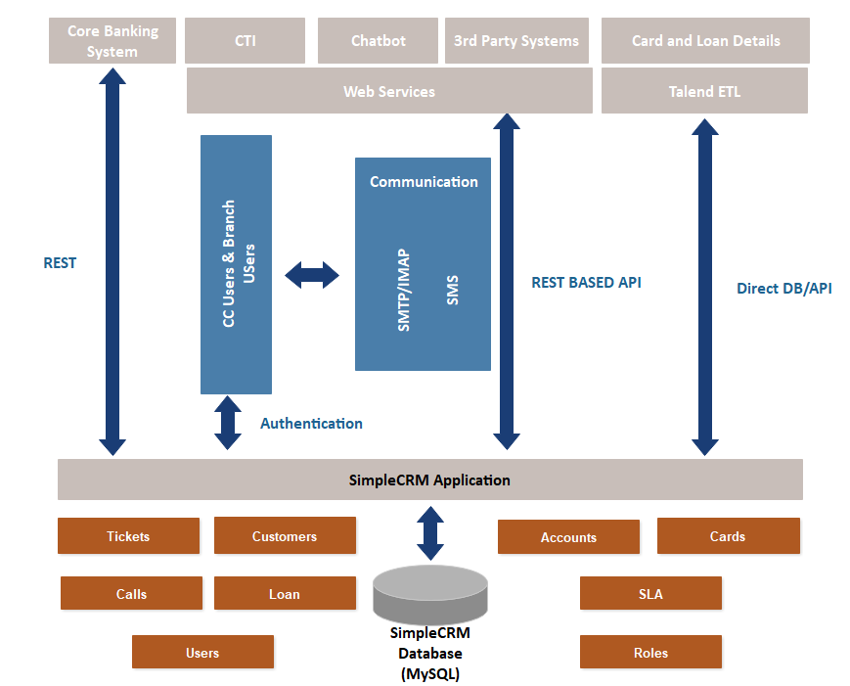

Network Architecture

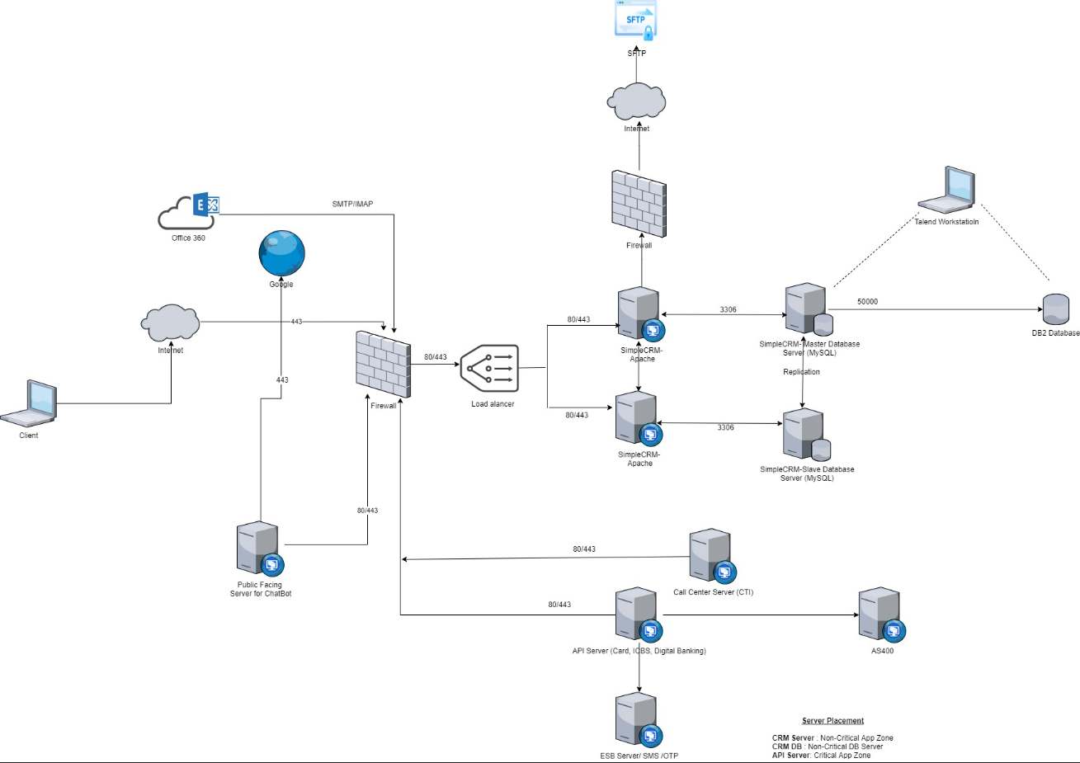

Integration Process

Data Stored in CRM

System | Frequency | Communication
Customer Info | - Daily Once (Completed Updated Data) | One Way (Core System to CRM)
Customer Info | - New Customer Data (Real Time) | One Way (Core System to CRM)
Account Info | - Daily Once (Completed Updated Data) | One Way (Core System to CRM)
Account Info | - New Customer Data (Real Time) | One Way (Core System to CRM)
Card Info | - Daily Once (Completed Updated Data) | One Way (Core System to CRM)
 | - New Customer Data (Real Time) | One Way (Core System to CRM)
Loan Info | - Daily Once (Completed Updated Data) | One Way (Core System to CRM)
 | - New Customer Data (Real Time) | One Way (Core System to CRM)

The above integrations except for the core system (Customer, Account) are available for all the users of the system. However, information related to other integrations available only to call centre keeping bandwidth availability on the Branch office locations.

Entity Relationship Diagram

The following ERD depicts the core entities and relationships that define the COM BANK CRM project scope

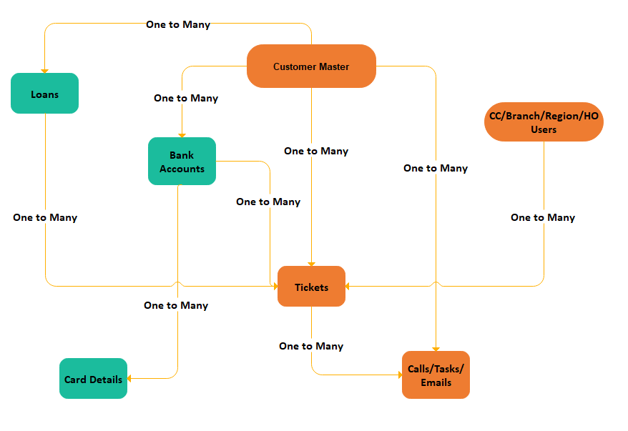

 | Only static data is covered as part of the ERD, Dynamic data Eg: Last 5 transactions are not stored in CRM.

System Overview (Service Management)

Currently, the Tickets created through various sources
- Customer calling Call centre
- Customer visit to the branch
- Customer visit to the Card Centre
- Customer Self-service chatbot
- Customer emailing Call centre

Chatbot UI is mobile Responsive. However, there may slight changes needed on how the options are displayed for the mobile device depending on the form factor.

Customer Calling Call Centre (Verification Questions)

Customer calls to call centre for a variety of enquires/issues. The COM BANK IVR initially asks for the Language preferences and routes the call to a specific Agent.

The agent would then verify the customer based on below questioner (The below questions randomized, 05 Questions shown at a time and it should include minimum two static & two dynamics)
    - Mother’s Maiden Name (Statistic)
    - Date of Birth (Statistic)
    - Registered Email Address (Statistic)
    - Direct debit account number
    - Do you have any facilities (Loan / Lease) with the Bank and the amount?
    - The number of savings/current/fixed deposit account.
    - Joint party's name in the saving / current account
    - Do you have any supplementary cards?
    - Last Deposit date & Amount.
    - Statement Date & Due Date.
    - Registered Mobile Number. (Statistic)
    - Last Login (Digital Banking)
    - Primary Account Number (Digital Banking)

Once the above information is confirmed, the agent provides necessary assistance to the customer.

Current Process:

Currently, there are no systems maintained on the branch level, and all cases are either logged in Excel or as notes

To Be process:

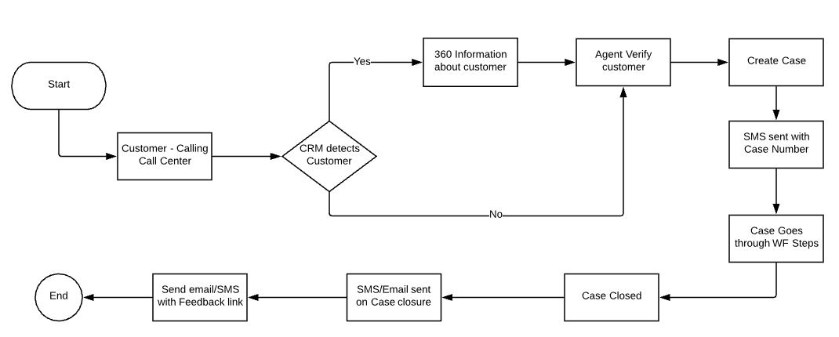

Customer visit to the branch

When the Customer visits any branch (Home Branch or any nearest Branch) to raise a ticket. The Branch agent (BA) will log the case in the Branch support portal with his credentials

The case now can take a different path based on the Case type

      - Branch can close the ticket
      - Branch can assign the ticket to a specific Branch or Department

In both cases, the customer to get Email/SMS notifications on case creation and close status

On the branch Level, only the Branch Manager can close the ticket after verifying with the Agent.

Customer Self Service using Chatbot

Customer Self-Service Chatbot offers to create Service Request/Enquiry to the customer. The chatbot is integrated with CRM to perform the following

- Get Product Information
- Integration with OTP for Customer validation
- Integration with CRM for retrieving customer information like accounts and cards
- Integration with Core Banking system to get Account transactions details
- Creation of Tickets for top 5 case types
- Getting status of Tickets
- General Information to Prospects/Leads

To Be Process:


Chatbot flows to be confirmed by Bank

Functional Requirements

Detailed Requirements

Managing Customer information

Requirement [RQ.1.0.0.1]: Customer Information

The system allows to capture and update customer information. Following table provides module-level field definitions.

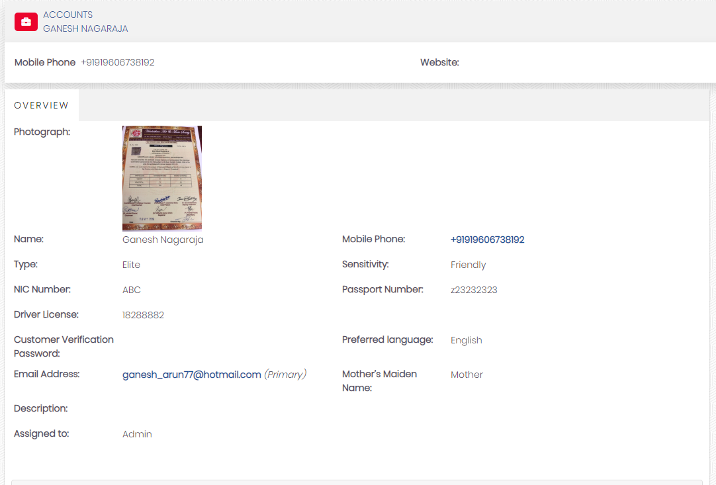

Field details

Display Name | Type | Values | Comments
Photograph | Image |  | Refer: RQ 1.0.0.7
Salutation | Drop Down |  | This field is used for now
Customer Full Name * | Text (255)
Customer Short Name | Text (255)
NIC Number * | Text (255)
Passport Number | Text (255)
Driving License Number | Text (255)
Date of Birth: <Age> | Date |  | Age Auto Calculated
Gender | Gender |  | Refer : RQ 1.0.0.3
Customer Category | Drop Down
Customer Priority | Drop Down
Sensitivity Category | Drop Down
Customer Verification Password | Text (255)
Mobile number – CBS (Core Banking System) | Text (255)
Mobile number – CMS (Card Management System) | Text (255)
Telephone number - CBS | Text (255)
Telephone number – CMS | Text (255)
Email address –CBS | emails
Email address –CMS
Correspondence Address - CBS | Text (255)
Correspondence Address – CMS | Text (255)
Mother’s Maiden Name | Text (255)
Occupation | Text (255)
EKYC | Text (255)
Preferred language | Integer
Date Created | Date time | Auto
Created By | User | Auto
Date Modified | Date time | Auto
Modified by | User | Auto
Assigned To | User | Auto

* Mandatory Field

Requirement [RQ.1.0.0.2]: NIC Search Logic

Currently, the Core system would have NIC in two different formats. CRM should have the option to search NIC using both the forms. CRM to implement Regular Expression for the NIC field.

Requirement [RQ.1.0.0.3]: Calculate Age based on Date of birth

Age of the customer to be automatically calculated based on the Date of birth

Formula: Age: Current Date – Date of birth

Requirement [RQ.1.0.0.4]: Gender identification of the customer

NICs issued before 1st January 2016, each NIC has a unique 9-digit number, in the format 000000000A (where 0 is a digit, and A is a letter). The first two digits of the number are the holder's year of birth (e.g.,91xxxxxxxx for someone born in 1991). The next three letters contain the number of days in the year of the person's birth. For females, 500 is added to the number of days. The next three digits are the serial number of the issued day. The next digit is the check digit. The final letter is generally a 'V' which indicates that the holder is eligible to vote in the area. In some cases, the final letter can be 'X' which usually indicates the holder is not eligible to vote; possibly because they were not permanent residents of Sri Lanka when applying for a NIC.

Conversion of Old NIC number to New NIC number
 | Birth  by year | Birthday  of the year | Serial Number | Check Digit | Special letter
Old NIC number | 64 | 104 | 275 | 7 | V/X
New NIC number | 1964 | 104 | 0275 | 7 | -

NIC number since 2016

From 1st January 2016, each new NIC has a unique 12-digit number. The first four digits of the number are the holder's year of birth (e.g.,19960223543V for someone born in 1996). The next three digits contain the number of days in the year of the person's birth. For females, 500 is added to the number of days. The next four digits are the serial number. The last digit is the check digit.

Requirement [RQ.1.0.0.5]: Random Verification question

Verification questions dynamically picked from a set of questions (2 Static and 2 Dynamic). Questions module will have the following field definitions.

Field details:

Display Name | SimpleCRM Field | Type | Values | Comments
Question ID | id | Varchar (36) | Auto
Question Name | questionname | Varchar (255) | Text
Question Type | questiontype | Drop Down | Dynamic: Static
Status | status | Drop Down | Active: Inactive

Only the Admin user to have access to the module to create/Edit any questions. When the 360 Degree view is loaded, the only questions with status “Active” are available as verification questions.

Requirement [RQ.1.0.0.6]: Daily Sync Updates/Creation of Customer, Accounts, Cards and Loan Data

Bank’s Core System tosend the update to CRM realtime via API and the following parameter to be passed to CRM to initiate the Scheduler Job

Module: SCRM_BANKJOBSSTATUS

API Request:
Entity | Customer: Accounts: Cards: Loans: Branches: ATM: Rates: Forex
Jobdate | DateTime (YYYY-DD-MM HH:MM:SS)
API Response:
Status: Success

Talend Job tomonitor the SCRM_ BANKJOBSSTATUS every 15 minutes and check the Jobdate. Sync Process to start, as mentioned in the below flowchart.

The Talend Job to run as a CRON Job on the MySQL database server which to connect to CRM Database directly and populate data. The mapping of fields is done on the Talend Job using Talend Open Studio.

Talend connects to DB2 Database View for each Entity mentioned above and syncs data into CRM, and once the job completes, email is sent to predefined email addresses.
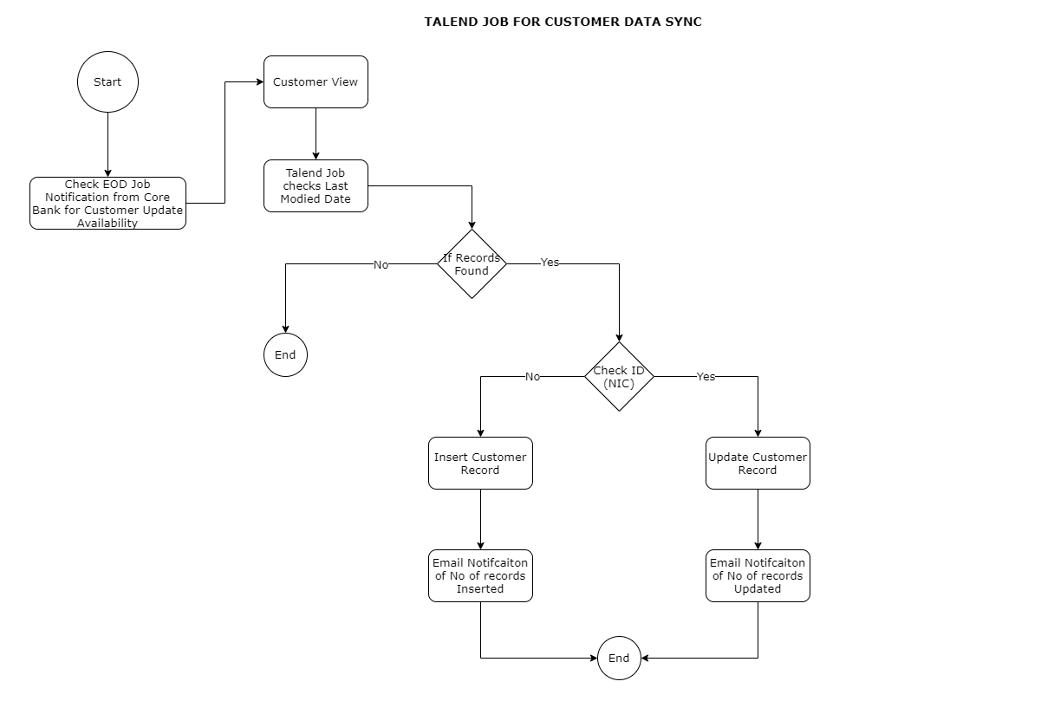

Requirement [RQ.1.0.0.6]: REST API for Creation of Customer, Accounts, Cards

When a new Customer. Account or Card data is created in Core System. The CRM System to consume CRM Web services to create the record on the CRM Side Real Time.

Following web services to be created

      - Create Customer
      - Create Account
      - Create Card

Requirement [RQ.1.0.0.7]: Ximager Storage for retrieving Customer Photo

Details to be provided by Bank

Requirement [RQ.1.0.0.8]: Customer Search Capability

Search on the customer should be possible on following fields (Customer Module)

- NIC
- Passport No.
- Driving License No.
- Account No.
- Mobile No.
- Date of Birth
- E-mail
- Address
- Ticket No.

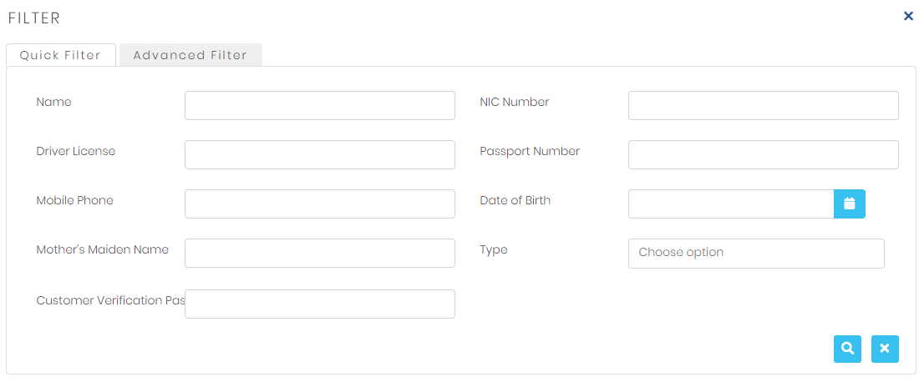\
Search Filters

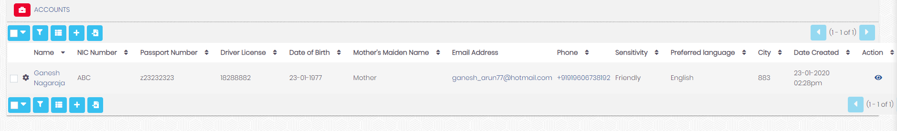Search Result List

Requirement [RQ.1.0.0.9]: Verification Question

Display Name | SimpleCRM Field | Type | Values | Comments
Question Name* | Name | Text (255)
Question Type* | Question_type | Drop Down | Dynamic: Static
Status | Status | Drop Down | Active: Inactive

On the Customer 360, the agent will list of verification question where system to display minimum two static & two dynamics when the call is received by the agent.

Managing AccountInformation

Requirement [RQ.2.0.0.1]: Account Information

The system allows to capture and update account information. Following table provides module-level field definitions. There are three types of accounts managed in CRM; they are Savings, Current and Fixed accounts

Field details

Display Name | SimpleCRM Field | Type | Values | Comments
Account Number | Name | Text (255) |  | (In the Account No Middle 5 numbers to be masked)
Account Type | Account_type | Drop Down | Saving: Current: Fixed
Account Status | Acctopendate | Drop Down | Active: Inactive | The status description should be displayed using a cross-reference file
Account Open Date | Accountstatus | Date
Product Type | producttype | Relate (product) |  | Product code & Description to be Displayed (Product description should be displayed using a cross-reference file)
Currency Type | Currencytype | relate (Currency) |  | (Currency description should be displayed using a cross-reference file)  If the currency is not LKR, then it should be shown in RED colour
Relationship | Relationship | Text
Last Activity Date | Lastactdate | Date
Branch Code | branchcode | Relate (Branch) |  | Branch Name & the Code to be Displayed (Branch description should be displayed using a cross-reference file)
Interest Rate | intrate | decimal
Year to date Average Balance | yrofdate | Decimal
Established Limit with interest rates | Limitrates | Decimal
Interest Disposition | Intdisposition | Text |  | Shown when Fixed Deposit
Transferring Account | Transact | Text |  | Shown when Fixed Deposit
Maturity Date | Maturitydate | Date |  | Shown when Fixed Deposit
Last WHT Paid amount | Whtpaidamt | Currency |  | Shown when Fixed Deposit

System to have separate modules for Accounts and loans as the attributed are different.

Managing Card Information

Requirement [RQ.2.0.0.2]: Card Information

The system allows to capture and update account information. Following table provides module-level field definitions.

Field details

Display Name | Type | Values | Comments
Card Number | Text |  | Masked Number is stored in CRM
Type | Drop Down |  | Credit: Debit: Pre-Paid
Card Account Number | Text |  | Shown when Type is Credit Card
Token Number | Text |  | Not Shown On UI
Participant ID | Text |  | Not Shown On UI
fdaStatus | Text
Active /Inactive Status | Drop Down
Pending Activation | Drop Down |  | Yes: No
Card Limit | Text
Temporary Limit & Expiry | Text
Card Expiry | Text
Last Statement Date & Balance | Text
Block ATM Withdrawals | Drop Down |  | Yes: No
Block International | Drop Down |  | Yes: No
Block Online | Drop Down |  | Yes: No
Last payment Date & amount | Text
Cycle to Date Payments | Text
Minimum Payment & Due date | Text
Limit Profile | Text
Primary A/C | Relationship | SCRM_Accouts | Only for Debit Card
unspecified A/C | Relationship | SCRM_Accouts | Only for Debit Card
Customer | Relationship | Customer

Last 10 Transactions to be shown in this manner. ZTAHST0P
Card Token | Transaction date | Tran Time | Billing Date | Tran Type | Posting Description | Transaction Currency | Transaction Amount | Billing Currency | Billing Amount | Transaction Status  (Held / Post)

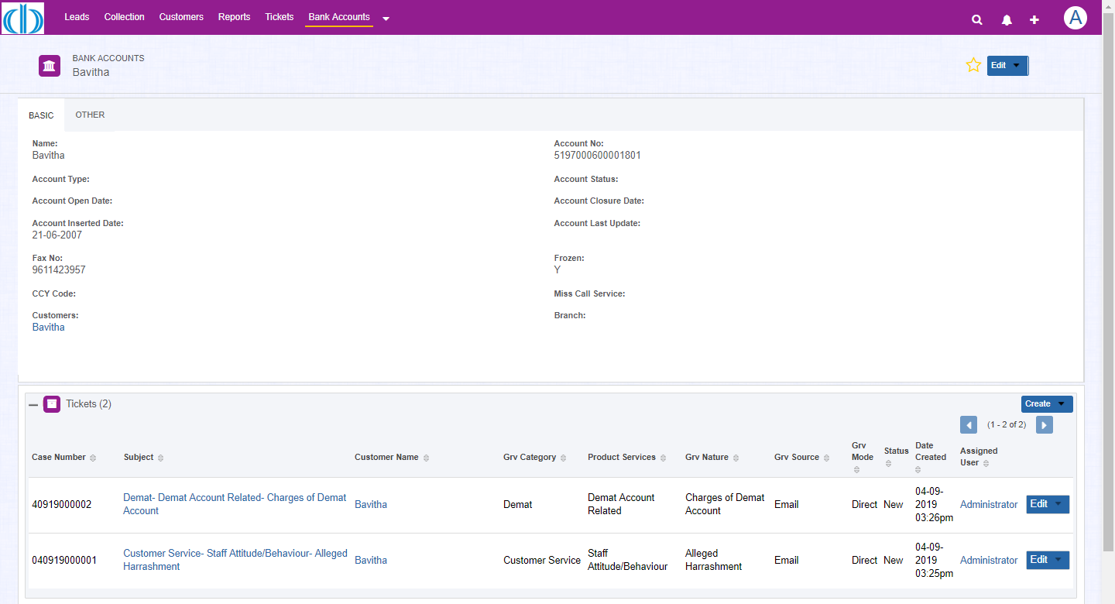

Primary Module | Relationship Type | Child Module
Customer | Many to Many | Account
Account (Products) | One to Many | Cards
Customer | Many to Many | Cards
Customer | Many to Many | Loans

Managing Loan Details

Requirement [RQ.2.0.0.3]: Loan Information

The system allows to capture and update Loan information. Following table provides module-level field definitions.

Display Name | Type | Values | Comments
Loan Number | Text
Loan Ticket Number | Text
Loan Status | Text
Loan Open Date | Date
Maturity Date | Date
Interest Rate | Decimal
Interest Type | Text
Product Type | Text
Currency Type | Text
Relationship | Text
Instalment Amount | Currency
Overdue Installments | Integer
Branch Code | Relate (Branch)
Collateral | Text

Primary Module | Relationship Type | Child Module
Customer | One to Many | Loan Details

Customer 360 Degree

Requirement [RQ.2.0.0.4]: 360 Degree – Pop-Up Screen Layout

When aCustomer profile viewed in 360 Degree view, the following sections show up for the agent

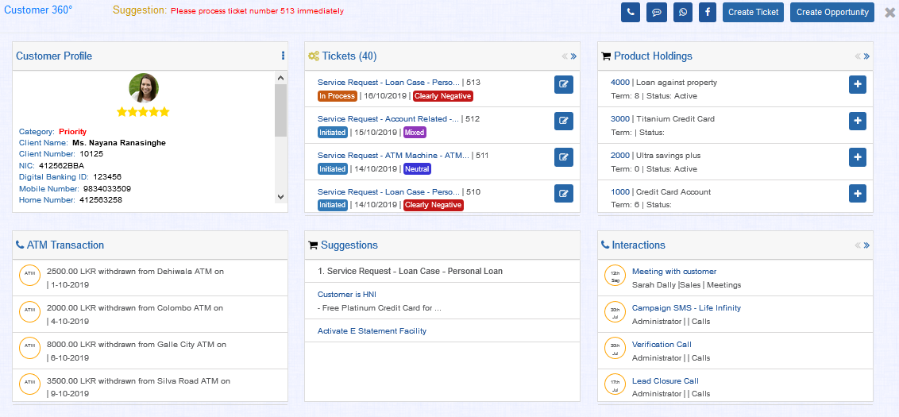
360 Degree View

*Actual implementation might change

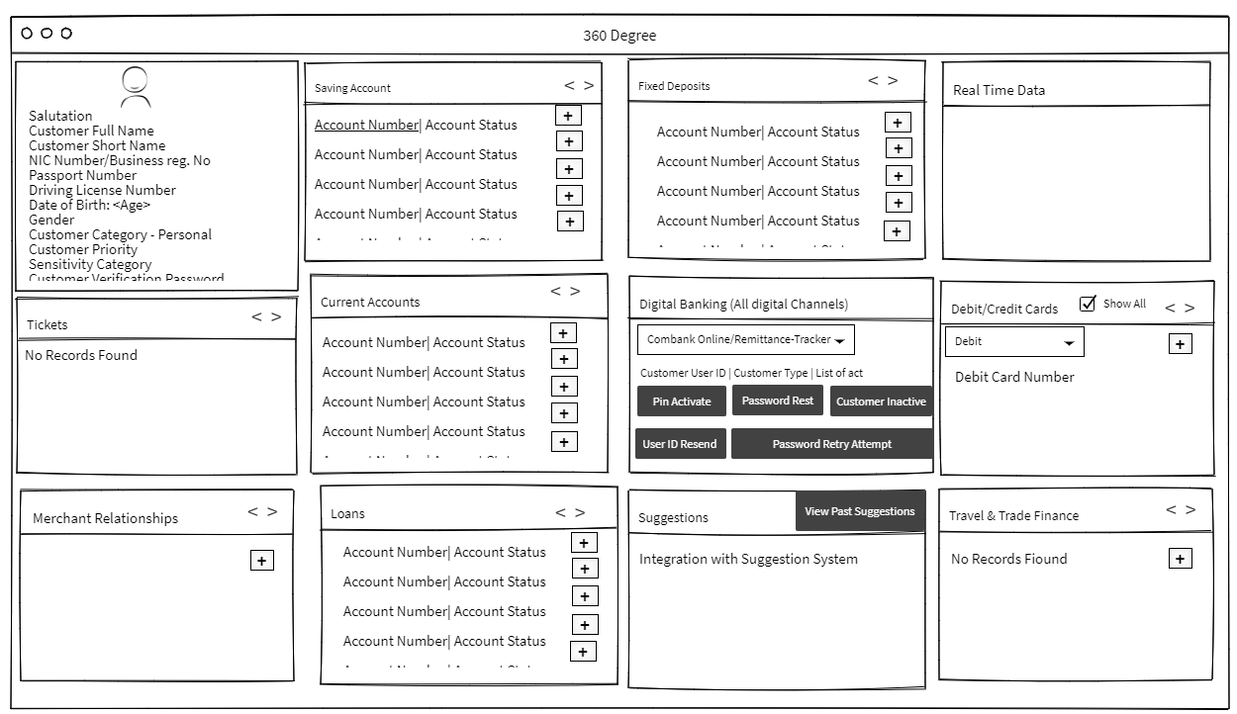

On the Flip Side of the Panel

- User Flips the planel to view Static Data from CRM
- Clicks on Get Data
- Real time Data Panel will show the real-time data for that selected enity
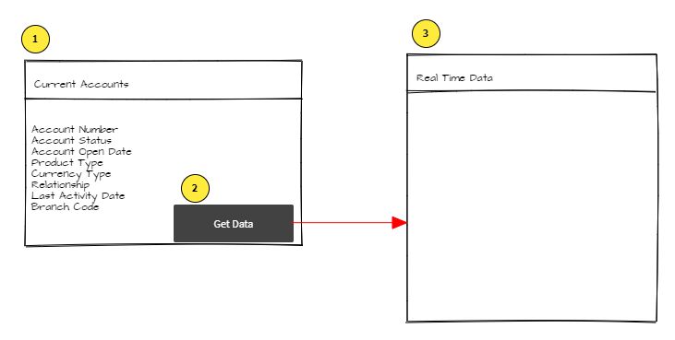

Managing Ticket information

Requirement [RQ.3.0.0.1]: Ticket Information

The system allows to capture and update Ticket information. Following table provides module-level field definitions.

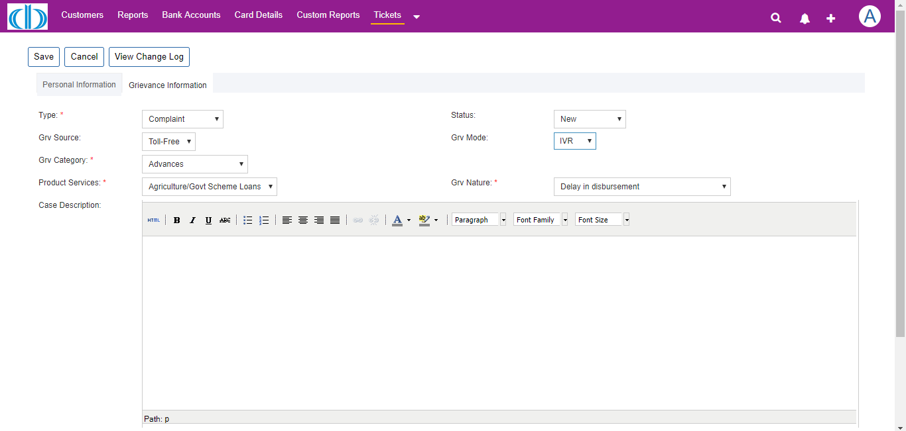

Field details
Field Name | Field Type | Values | Dropdown Values
Subject * | Text
First Call Resolution * | Checkbox
Source * | Drop Down | Email: Call Center: Branch: Letter: Others
Status | Drop Down | New: Assigned: In Progress: Closed Valid: Closed Invalid: Duplicate
Category * | Drop Down | Inquiry  Complaint  Service
Type * | Drop Down |  | Values to be Updated
Grievance Category* | Drop Down |  | Values to be Updated
Grievance Nature* | Drop Down | New: Assigned: In-progress: Closed- Valid:  Duplicate:  Re-open:  Closed- Invalid
Ticket Closed Date | Date Time |  | Automatic when Status changed to Closed  Read-Only. Shown if the status is Closed
Ticket Re-Open Date | Date Time
Ticket Closed- Invalid Reason | Text Area
Re-Open Reason * | Text Area
Priority * | Drop Down | High  Medium  Low
Account No: * | Drop Down | List of Accounts | Auto Picked from 360 Degree  If case is triggered against Card, then Account is auto selected.
Customer No: * | Text |  | Auto Picked from 360 Degree
Card Number | Drop Down | List of Cards based on the Accounts | Auto Picked from 360 Degree- If case is triggered against Card, then card is auto selected.
NIC: | text
Source | Drop Down | Walk-in:  Sales agent calling on behalf of the customer  Call:  Email:  Fax:  Post:  Portal:  Facebook:  Twitter:  Viber:  WhatsApp:  Skype
Description | Text Area
Resolution | Checkbox
Additional Comments | Text Area |  | The agent uses this field if the Customer is calling from a different number which is not registered
Preferred language | Checkbox | Visible to all | Auto filled from Customers
Contact Number | Text Area |  | Auto filled from Customers
Email address
Feedback preference | Email / SMS |  | Auto filled from Customers
Created by |  |  | With date & time
Assigned to |  |  | With date & time
Last modified by
Assigned Branch/Department * | Branch | Relate(Branch) | Requirement [RQ.3.0.0.7]: Assignment Rule for Tickets
*Mandatory
Example of ticket creation
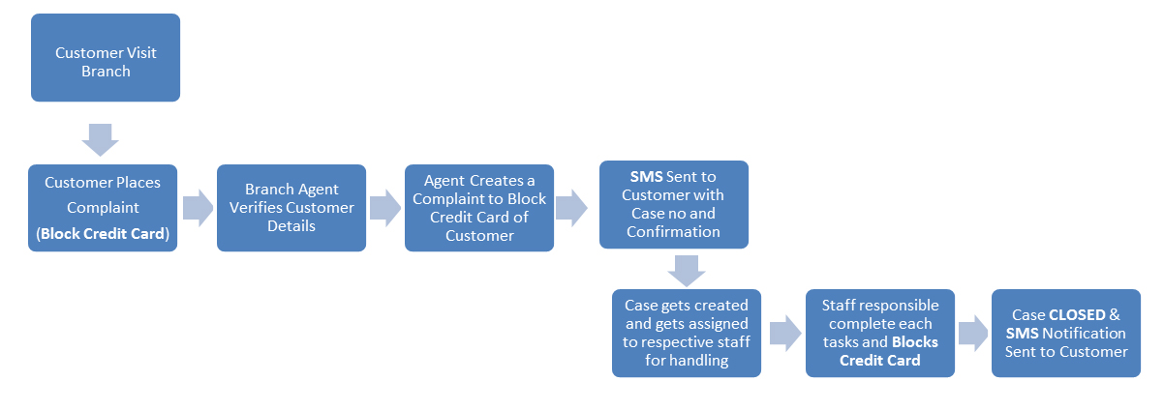

Requirement [RQ.3.0.0.2]: Inbound Email Case creation process

ComBank has a couple of emails that are exposed to Customer to send out their Support requests/Grievances to the bank. These emails are currently managed by Card centre, Marketing or by the operations team. Once the bank receives emails; the department reaches out to various stakeholders as per need. The basically communicate via email and track the progress and finally communicate the resolution to the customer.

To Be Process:

Currently, the emails received on some centralised emails like info@combank.net monitored by Person, now tracked by CRM and then create Case for each email that arrives on the inbox.
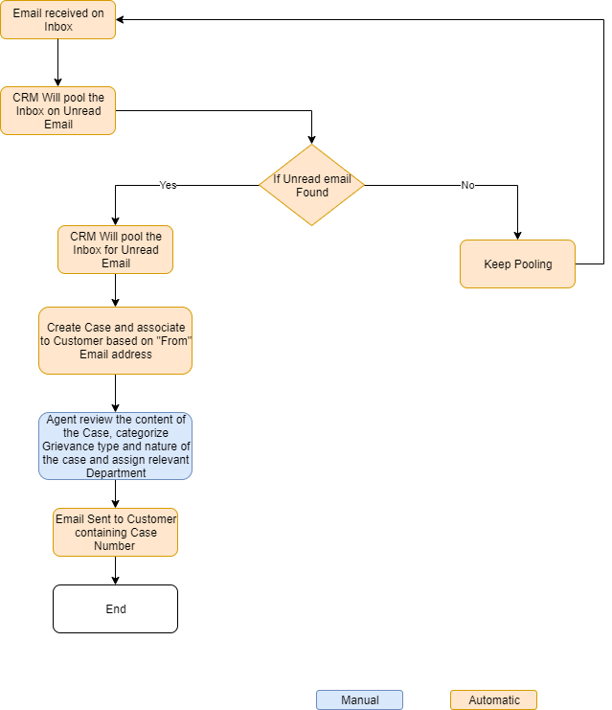

The agent reviews the cases created in CRM from an email assigns the cases to the relevant department. The department users using the CRM towork on the Case and close the Case. The below section defines the process/scenarios that needis managed in CRM

CRM – Case Edited by Call Center Agent, is assigned to Branch/Department |  | Department User |  | Branch User
Action |  | Ifthe case isAssigned |  | Ifthe case is NotAssigned
Edit | Close | Edit | Close | Edit | Close
  *** | If the case is Assigned |  |  | Not Accessible | Not Accessible

CRM – Case Edited by Call Center Agent, is assigned to Branch/Department |  | Department User |  | Branch User
Action |  | If the case is Not Assigned |  | If the case is Assigned
Edit | Close | Edit | Close | Edit | Close
*** | If the case is Assigned | Not Accessible | Not Accessible |  | 

*** Cases can be edited by Agent of Call Center and assigned to Branch or Department user

Communication between department and Branch defined below the process in CRM and Branch Support portal. The following channels used for communication

      - Tasks
      - Emails

CRM and Portal Interaction Matrix

Scenario 1: Case is assigned to a department and needs input from branch

The department user creates Tasks or Emails under Case module and sends the communication to the branch. The Branch user to accept and close the tasks to denote the tasks were completed by providing comment to tasks. Assigned tasks are available on the dashboard of the Branch Support Portal. However, the details of the cases are available for the branch to view.

CRM (Department) |  |  |  | Branch User
Tasks |  |  |  | Tasks
Create | Edit | Assign | Close | Create | Edit | Assign | Close
 |  | (Owner) |  |  |  |  |   (Assigned)
Created under Case

Scenario 2: Case is assigned to a Branch and needs input from department

The department user creates Tasks or Emails under cases in the portal and assigns the task to a department. The department user will log in into CRM and update task and close it

Branch User |  |  |  | CRM (Department)
Tasks |  |  |  | Tasks
Create | Edit | Assign | Close | Create | Edit | Assign | Close
 |  | (Owner) |  |  |  |  | (Assigned)
Created under Case

Process for Tasks

The Tasks created by the Department is assigned to Branch, below process explains the process.

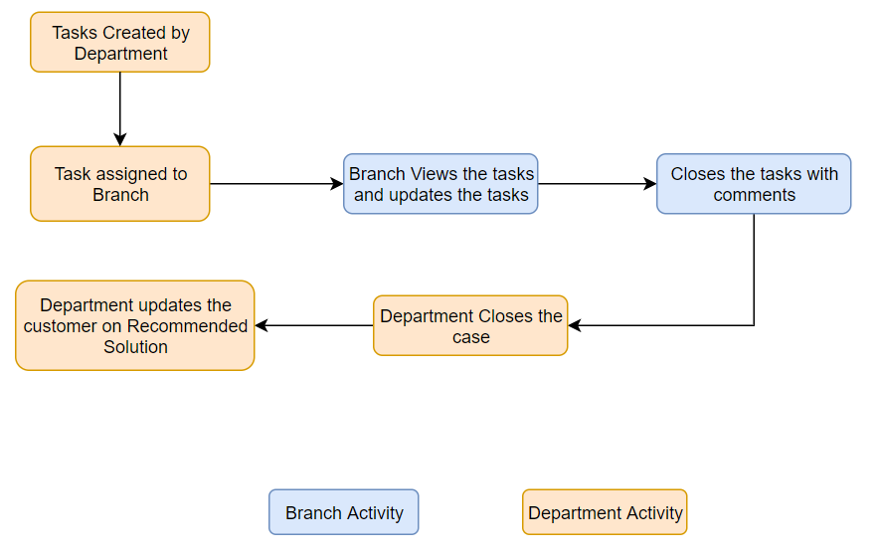

Email Communication between branch, department and the customer

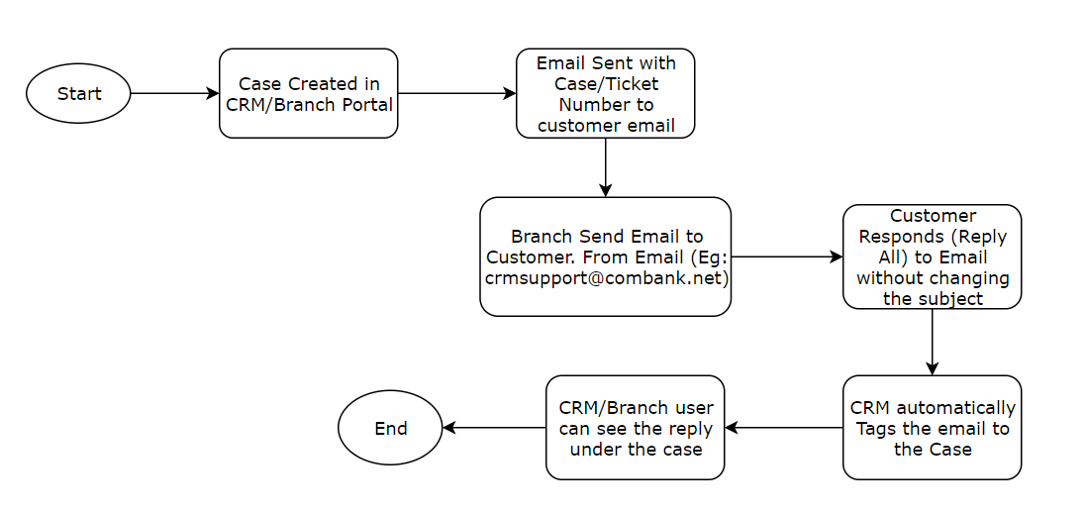

E.g.,Initially, Customer reports a service request on info@combank.net. CRM monitoredinfo@combank.net and creates a case. Automated email notifications to the customer on case creation goes from crmsupport@combank.net. Ideally, all communication going forward should happen crmsupport@combank.net, If the department wants to use their email, then CC the email to crmsupport@combank.net so that CRM can track all email communication.

Workflows&Ticket Assignment Rule

Requirement [RQ.3.0.0.3]: Workflow Configurations

The system should allow configuring attached Workflow Definitions.

Refer Annexure for more info (Section 12.2. Appendix B - Workflow Definitions)

Requirement [RQ.3.0.0.4]: Working Hour configurations

The System should allow configuring Working Hours (8:30 am to 5 pm). All the Workflow SLA’sbound by the time set on the Working Hours.Also, “Monday to Saturday” is considered and Weekend isSunday.

Requirement [RQ.3.0.0.5]: Holiday Calander

The System should allow to configure/import Holiday Calander for a selected period via CSV. SLA calculations should exclude the Holidays. Also, System admin to be able to add AdHoc holidays to the system.

Requirement [RQ.3.0.0.6]: Recalcuate SLA

The System will auto calculate SLA if a new holiday is created. A Scheduler will run once a day in the morning, to recalculate SLA for all open Tickets.

Requirement [RQ.3.0.0.7]: Assignment Rule for Tickets

A Ticket is created either by Call centre agent, customer service agent or by Branch. The Ticket will be assigned to the person who created the Ticket. Based on the various criteria the Ticketis assigned based on the Customer’s Account Branch, however, if the Ticketdoes not need branch assignments will remain with the agent who created the Ticket. The User will select a branch/department while creating a case based on which the case is assigned

However, each task will have predefined Role. The role determines who in the hierarchy are responsible for handling the Ticket tasks. The Team provides (Branch) includes the list of users who belong to the role. The system gets the list of users and will assign to one of the users automatically based on the Least Busy Agents

Escalation always happens based on the Reporting Hierarchy set on the User Level.

Email/SMS Notifications & Templates

Email Notifications – Auto Generated

Requirement [RQ.1.0.0.14]: Send Email Notifications on Ticket Create

Subject:[YOUR REFERENCE: #<ticket number>] <sub workflow name>
Dear <Salutation><Customer Name>,

Thank you for contacting us!

We have received your <category>,and our support team will reach out to you shortly. Your reference number is<ticket number>. Please use this reference number for further communication related to this <category>.

Best Regards,

Team Commercial Bank


Requirement [RQ.1.0.0.15]: Send Email Notifications Ticket Closure

Subject: [your reference: #<Ticket number>] <Sub workflow >
Dear <Salutation><Customer Name>,

We hope your <category> has been resolved to your satisfaction. This <category> has now been closed.

For further clarifications, please feel free to contact on 011-2461461 or forward your emails to help@combank.lk (email address has to change based on the responsible person, for ex: if the ticket is opened by customer service then email should be help@combank.lk, otherwise help@combank.lk )

In our continuous endeavour for service improvement, we request you to spare a few minutes and answer five questions that help us understand your experience with us. Please click on the below URL to go to our feedback survey form:

please rate our service (if we Click here it will open a page for submitting the feedback)

Regards,
Team Commercial Bank

Requirement [RQ.1.0.0.17]: Send Email Notifications on Ticket/Record Assignment.

Subject: Assignment | <Account number>
Dear <Assigned User>

A Ticket is assigned to you; pleaseattend theTicket byClicking <link to Record in CRM>

Regards,
Assignees Name, Department

Requirement [RQ.1.0.0.18]: Send Email Notifications for Ticket Escalations.

Subject: [<Account number>>] <Ticket Subject>
Dear <Assigned User>

The below-mentioned ticket is open for<hours> hours.
Reference : <ticket number>
Subject: <ticket subject>
Description: <ticket description>
Priority: <ticket priority>
Assigned to : <assigned user>
Ticket URL: <URL of the ticket>
Next Escalation: <Name of next Escalation>

Please attend to this immediately

This is a system-generated email. Please do not reply.

SMS Notifications

Requirement [RQ.1.0.0.19]: Send SMS Notifications Ticket Creation

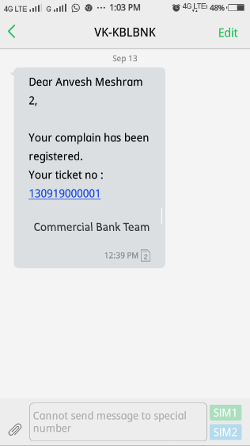

Dear Accountholder

The ref number for your request is : <Ticket number>] - <>
Reported on: <Date Created>
Team Commercial Bank

Requirement [RQ.1.0.0.20]: Send SMS Notifications Ticket Closure

Dear Accountholder
Your request with the ref <Ticket number> has been attended and completed on
<Closure Date>. Please rate our service <feedback link>
Team Commercial Bank

Requirement [RQ.1.0.0.21]: Send SMS Notifications Ticket Re-Open

Dear Accountholder,

The ref number for your re-opened request is: <Ticket number>].
Reported on: <Date Created>
Team Commercial Bank

Managing Ticket – Closure Feedback information<SAMPLE>

Requirement [RQ.1.0.0.22]: Capture Customer Feedback upon Ticket closure

- Was your issue resolved the first time you reported it? (Yes/No)
- Was the relationship executive able to understand your requirement? (Yes/No)
- Was your <category> resolved to your satisfaction? (Yes/No)
- Would you recommend our service to others? (Yes/No)
- How would you rate your overall satisfaction with Commercial Bank Support?(1,2,3,4,5) 1 being the lowest and 5 being the Highest.

SMTP Settings

Requirement [RQ.1.0.0.23]: SMTP Configurations for email Notifications to Customers/Internal

The systemtoprovide an option to capture SMTP Setting for email notifications to Customers/Internal
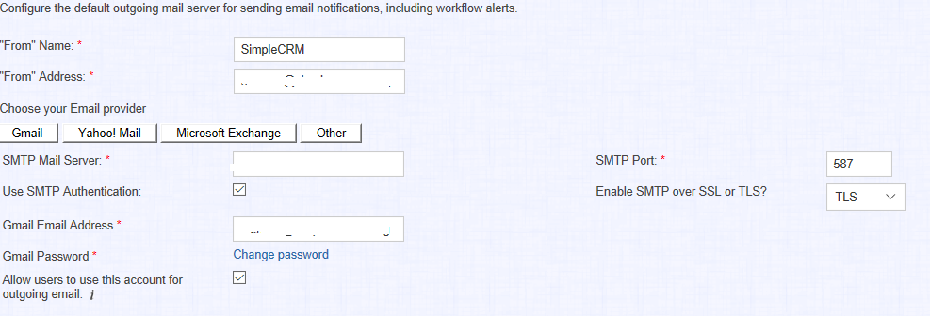
Typically following information required
        - SMTP Mail Server
        - “From” Email address
        - User Name
        - Password
        - SMTP Port

View Integration Data

Integration related data can be viewed from two places.

- 360 Degree View
- Customers->Account Sub-Panel

Requirement [RQ.1.0.0.25]: Customers ->Account Sub-Panel

System to provide the option to view all integration related data from the Account Sections. However, the Integration isavailable only for the call centreanddepartment users

Once the user triggers the integration option, the UI as shown below appears

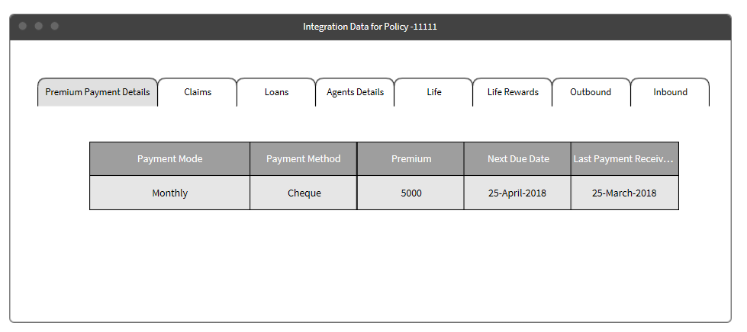

*Actual implementation might change

CRM and Portal Users

SimpleCRM users broadly classified as the following type of users

- CRM Admin Users
- CRM Regular Users

CRM Admin Users will have access to entire data and also have admin privileges to add, edit and deactivate users and other sets of features.

CRM Regulars Users are the business users will create the business data like Customer, Tickets, Tasks and other activities in the CRM. However, access to Data and functionalities are controlled by Roles

Broadly, Regular users are controlled by the following roles

      - CRM User Roles
      - Branch User Roles

Role definition for each of the above roles are defined in a separate Sheet

Application Users, Security Groups and Roles

SimpleCRM uses Security Groups to map the Branch and users. The user must belong on the security Group and to a role.

Roles

SimpleCRM Roles define permissions for users such as what kinds of records they can access and what level of access they are allowed. Roles work in conjunction with Teams to form a robust security model for non-admin users in SimpleCRM. Roles control two different layers of access for users within SimpleCRM: module and action-level access.

Administrators can create different roles and assign regular users to the roles. A user can be associatedwith any number of roles, and when multiple roles are applied, SimpleCRM adheres to a most-restrictive Account to determine the user's appropriate access levels. Administrators cannot be associated withroles as their administrative rights supersede any restrictions imposed by Role Management. The following table definition of the actions.

Action | Description
Access | Select whether the user should have any access to this module  If set to disabled, the user will not see a module tab for the module, any subpanels, or be able to access any records from this module
Delete | Ability to restrict users from deleting or merging records in SimpleCRM
Create/ Edit | Ability to restrict users from editing or creating records in SimpleCRM
Export | Ability to restrict users from exporting data from SimpleCRM to their local computers
Import | Ability to restrict users from importing data into SimpleCRM
List | Ability to restrict users ability to see records in a list view or subpanel
Mass Update | Ability to restrict users from using the Mass Update functionality in SimpleCRM, meaning that Mass Update will not appear as an option on the list view's Actions menu when this is restricted
View | Ability to restrict access to the detail view of specific records, meaning that when viewing a list view, the hyperlink to view the record's detail view will not be available and will instead show in plain text

Security Group
Security Suite allows control of what users can access. It will enable restricting sensitive data in SimpleCRM to specific teams (groups). SecuritySuite comes loaded with options which allow you to configure it to meet your exact needs. For this implementation, each branch or Department is a Security Group. Users are added to one or more security Groups/Branches.
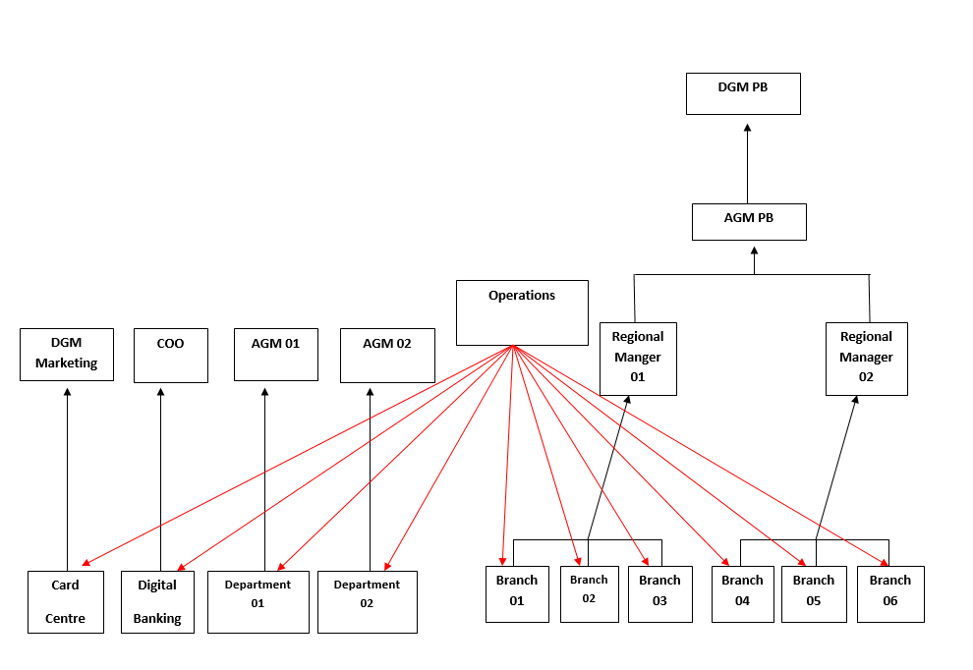

Requirement [AD.1.0.0.1]: Creation of Security Group

From the above Organization Diagram, the following Security Group to be created.
        - Card Centre
        - Digital Banking
        - Department 1 .. N
        - Branch 01
        - Brach 02 .. N
Each of the Branch and Department becomes a security Group. One or more users can be part of the security Group.

Requirement [AD.1.0.0.2]: Creation of Roles

Roles template is discussed with Bank; this section is updated once we get it from Bank

Requirement [AD.1.0.0.3]: Default Role

When a new user is created, by default “No Access” Role is added to the user. This role will restrict access to all the data and all the modules. Even if the user logs in to CRM, he/she will not have any access. Admin will have to remove the Role from the newly created users.

Basic System Setup for each User

To SimpleCRM work, configurations with Basic Parameters like default currency, system name, time zone, etc.

Please find information on Annexure “Employee Setup.”

CTI Integration

360 Degree Pop-up

Requirement [RQ.11.1.1]: Pop-up 360 Degree Pop-up for Registered Mobile Number

Below process is followed when the customer calls the call center and integration between CRM and CTI systems.

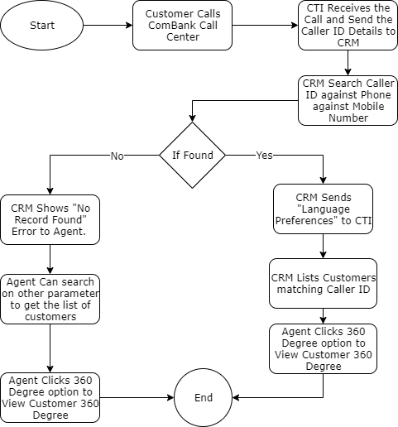

Appendix B - Advanced Workflow and Assignment Rules

To be Updated Later

Reports

Daily Sync

Branch Support Portal

The branch Support portal is a centralised system used by the Comercial bank branches across the island. The Branch has two types of roles
- Branch Executives
- Branch Manager

Branch Users
Executive |  |  |  | Manager
Edit/Create Case | Assign Case |  | Close Case | Edit/Create Case | Assign Case |  | Close Case
 |  |  | 
Edit Customer/Accounts |  | CreateCustomer/Accounts |  | Edit Customer/Accounts |  | Create Customer/Accounts
Not Available |  |  |  | Not Available

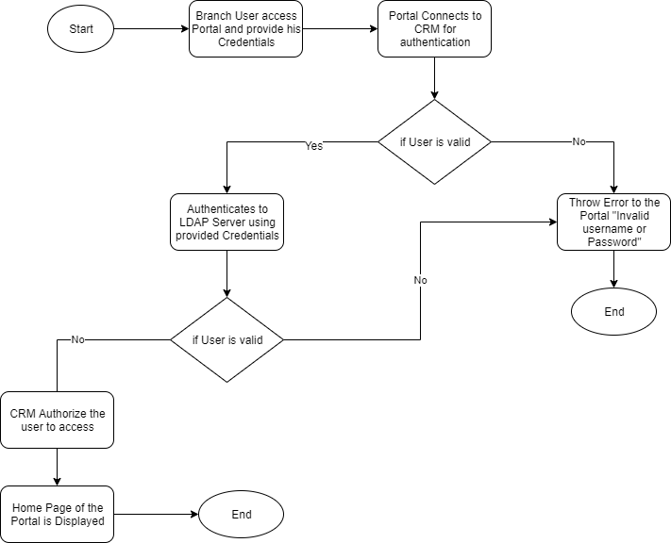
The communication between CRM and Branch support portal is using REST Based (HTTP), and no direct database access is provided.

On the portal, the following Modules exposed with a limited set of functionalities

      - Customer information
      - Case Information
      - Notes
      - Tasks
      - Emails with attachments

Customer information is not directly visible to the branch user; however, only the customer information related to the case isviewed.

The flow chart depicts the process of authorizing the user to access the portal. The LDAP Server performs the authentication and responds to CRM if the credentials are valid. If the credentials are not correct, then the CRM will display the error.

Dashboard

The dashboard has following Panels for portal users
  - My Tickets
    - List of Open Tickets assigned to Branch

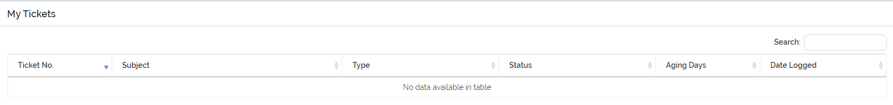
  - My Tasks
    - List of Open Tasks assigned to Branch
Task Subject | Case Number | Priority | Date Created
  - Chart for Ticket Status

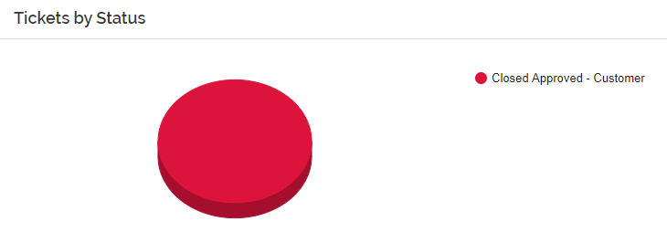

  - Chart for Ticket Type

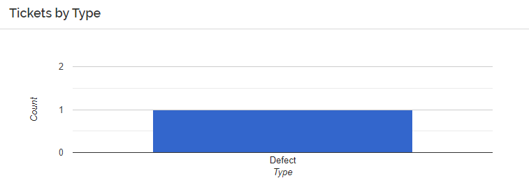

Customer Search

The cases can be search based on the following filters:
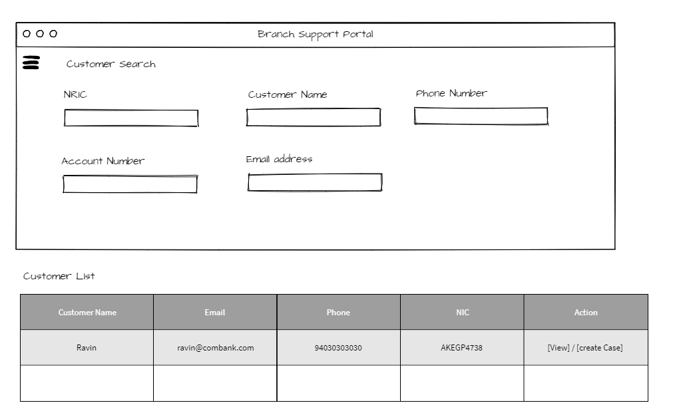
  - NIC Number
  - Customer Name
  - Email
  - Phone Number
  - Account Number

The Branch User will search for the Customer based on above set of fields, before creation of Case

Case Search

The cases can be search based on the following filters:
- Case Number
- Reported Date
- Priority
- Status
- Grievance Type
- Grievance Nature
  - NIC Number

Create/Edit Case

Log Issue feature in Portal will help the branch to create a Case and assign to Self-Branch or a different Branch/Department.
The branch can update the status of the case based on the progress done on the case

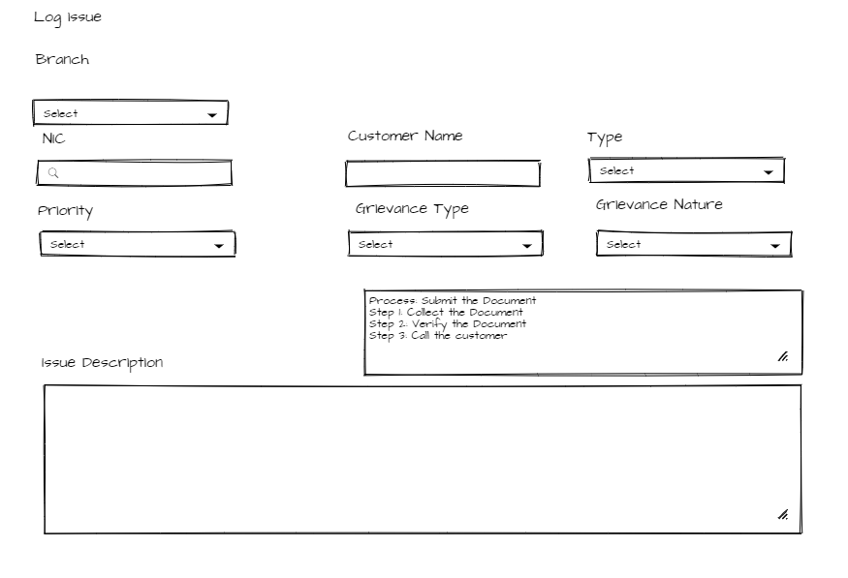

Once the Case is logged, Normal SLA process will initiated in CRM Side, However on the portal only Step details will be aviaalble.

View Case

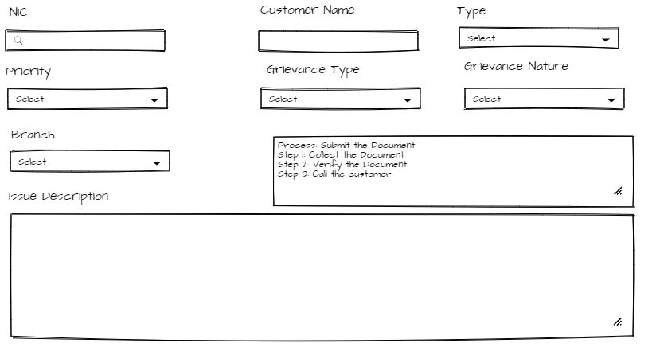
View Case Layout allows the agent to view the details about the case and also the steps that need to be followed by the branch to close the issue at the earliest.

Create Tasks/Notes

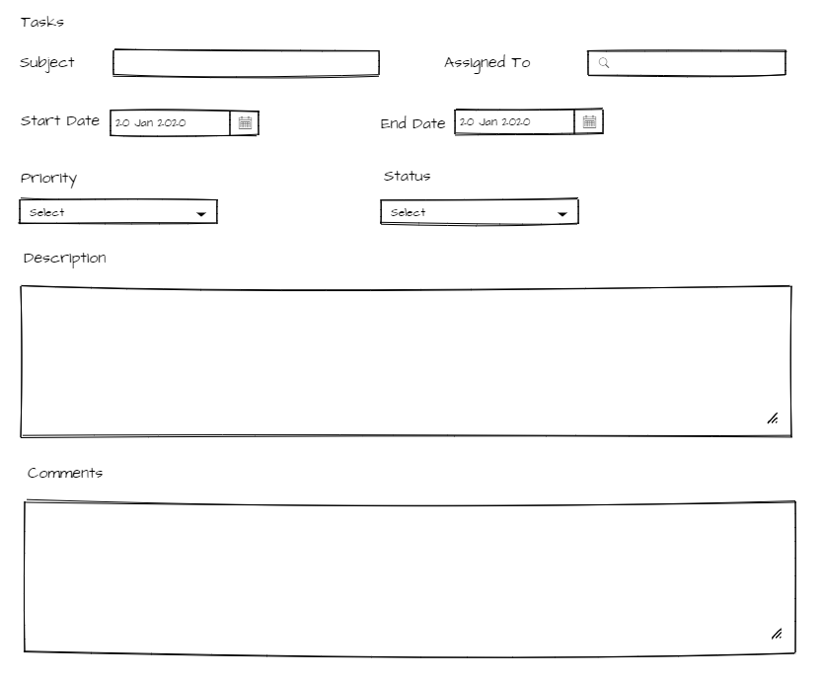
Task/Notes module used for internal communication between department and Branch. The Notes/Tasks module to have a Start Date and End Date and option to add documents. These notes are created under the cases module and cannot be a standalone task.

Close Task

The branch executive/Manager can close tasks that are either created by Self or assigned by various departments. The user can close the tasks by putting comments against each task.

Close Case

The branch manager will be authorized to close the case once all the tasks associated with cases are closed.

Reports

Reports – Age of Grievence

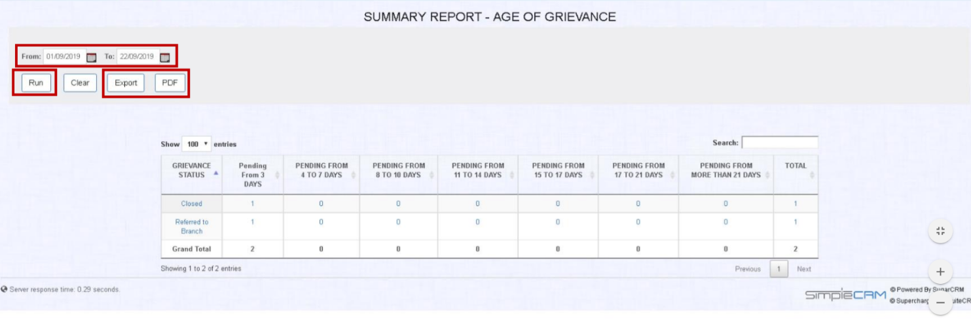

Reports – Case Priority Count

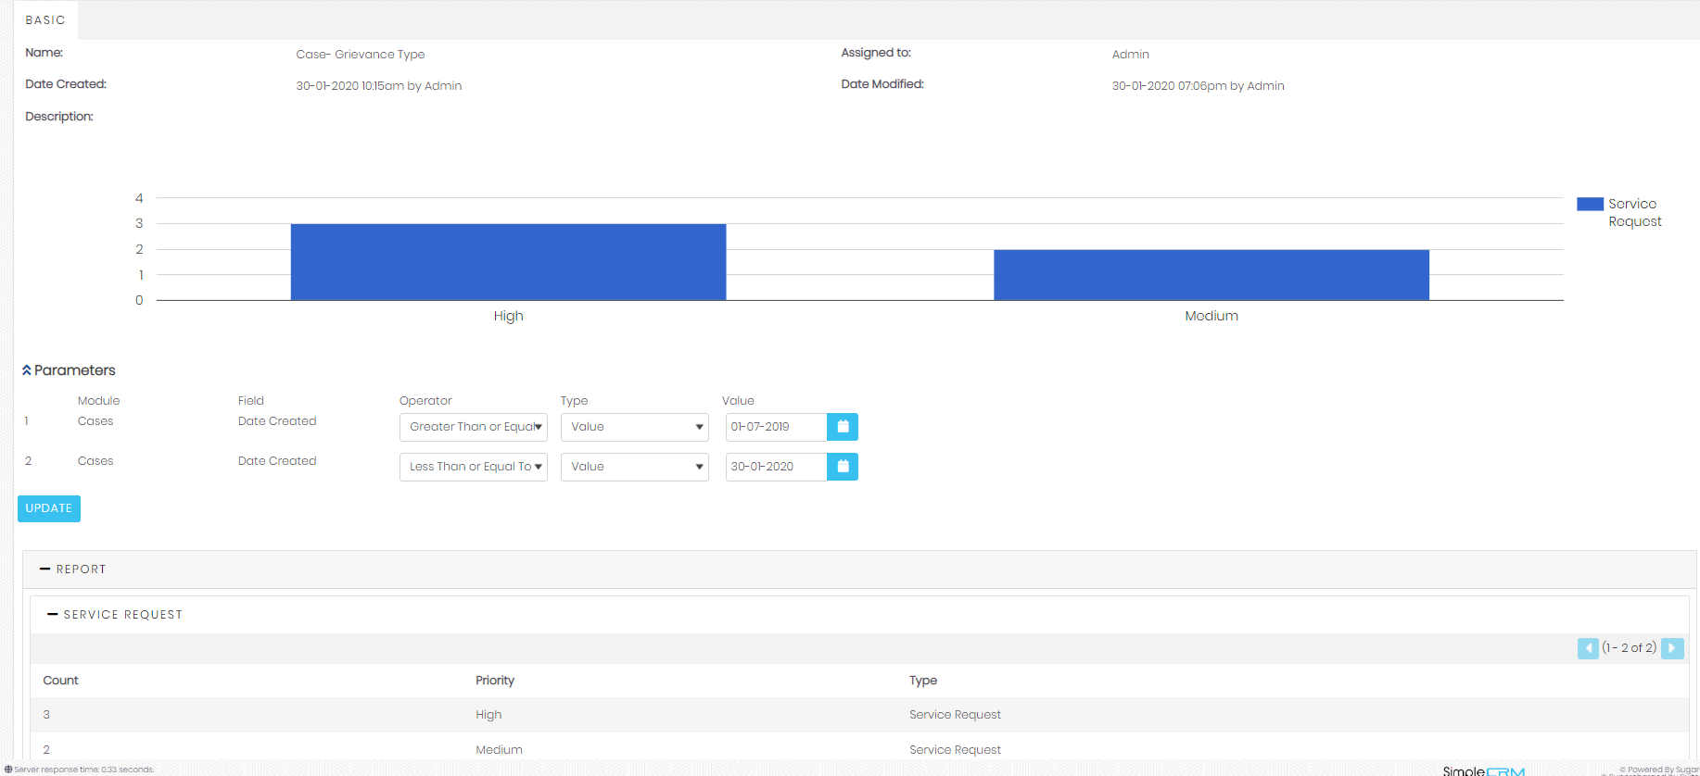

Reports – Case Type Count

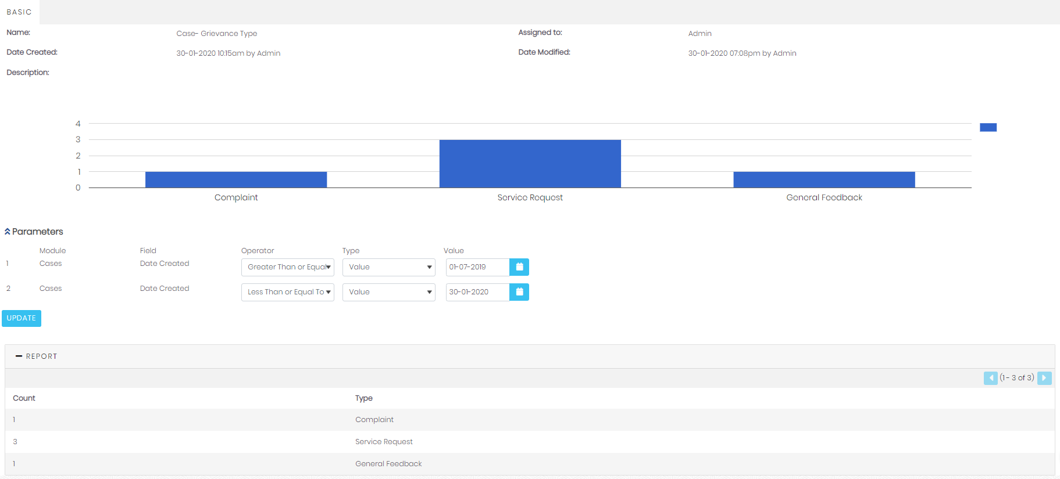

Chatbot Flows

Top View of Chatbot Flows

Current and Saving Products

Fixed Diposits and Tresury Bills

Loan and Leasing Details

Note: EMI Calculation process need to be finalized

Cards

Digital Banking Products

Other Products

My Products Top View

My Current and Saving Products

My Fixed Deposits and Treasury Bills

My Loan Details

My Card Details

